Consolidated report on Wazuh POC

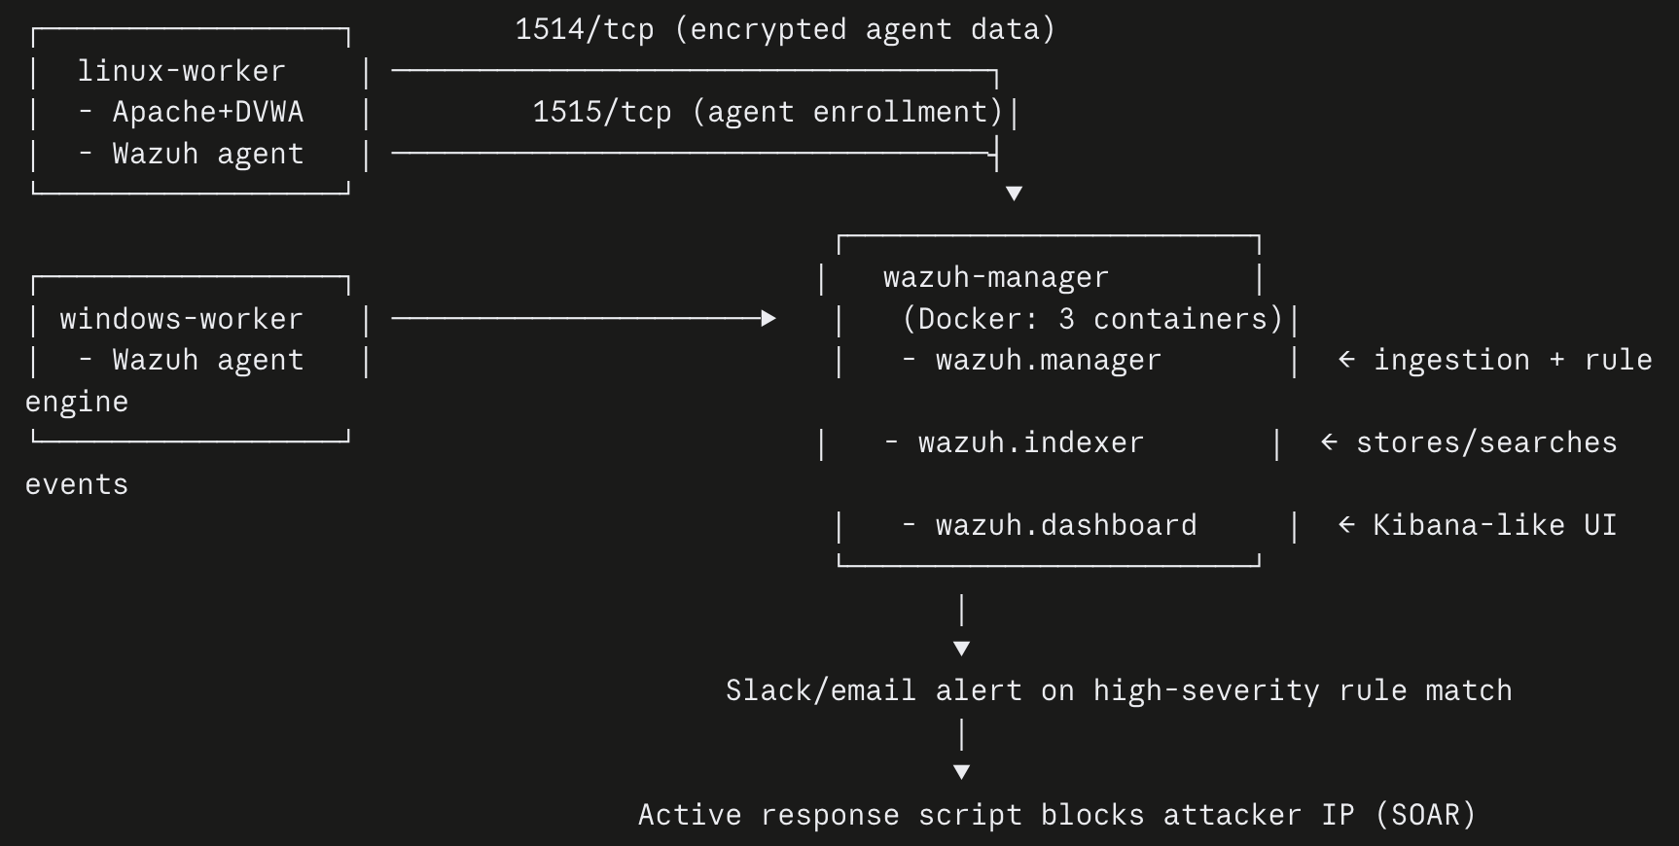

Wazuh SIEM/SOAR Proof of Concept - Report
Objective: To deploy a working Wazuh SIEM in an isolated AWS environment and demonstrate the full security operations loop ingest logs, detect two real attack types, alert, and be able to respond automatically, and visualize against a vulnerable target.
Architecture: 2 EC2 instances in a shared VPC - wazuh-manager (Docker: manager + indexer + dashboard) receiving logs from linux-worker (Apache/DVWA + Wazuh agent) over the Wazuh agent protocol (port 1514).
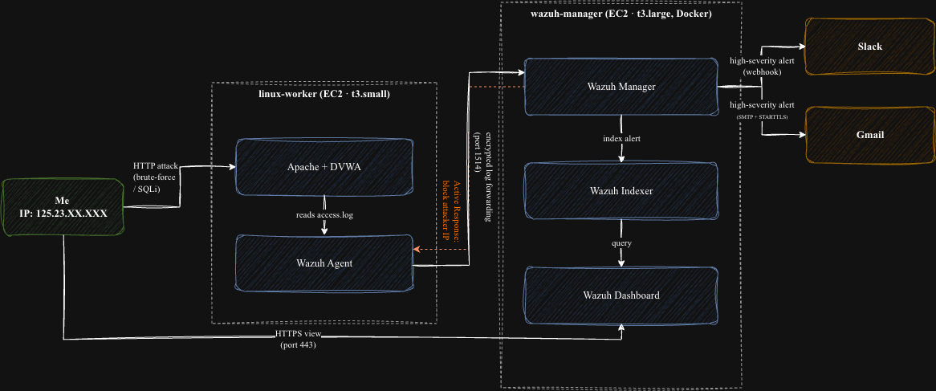

Phase 0 - AWS Infrastructure Verification
Objective: Confirm existing AWS resources (VPC, subnets, security groups, key pair).
So before spinning up any new AWS stuff I wanted to actually verify what was already there. So I ran a bunch of aws ec2 describe-* commands against the VPC, both subnets, all the security groups and the key pair.
- For linux-worker-sg had an old IP address rule left over from before instead of my actual current IP so had to revoke the old one and add the correct current IP
- And for windows-worker-sg added inbound rules for RDP (3389) and HTTP (80) scoped to my IP.
Result: Found and fixed 2 real drift issues linux-worker-sg had a stale IP from a previous network, windows-worker-sg had zero inbound rules despite notes claiming otherwise. Key pair had to be recreated (private key was never saved).
Screenshots:
  - 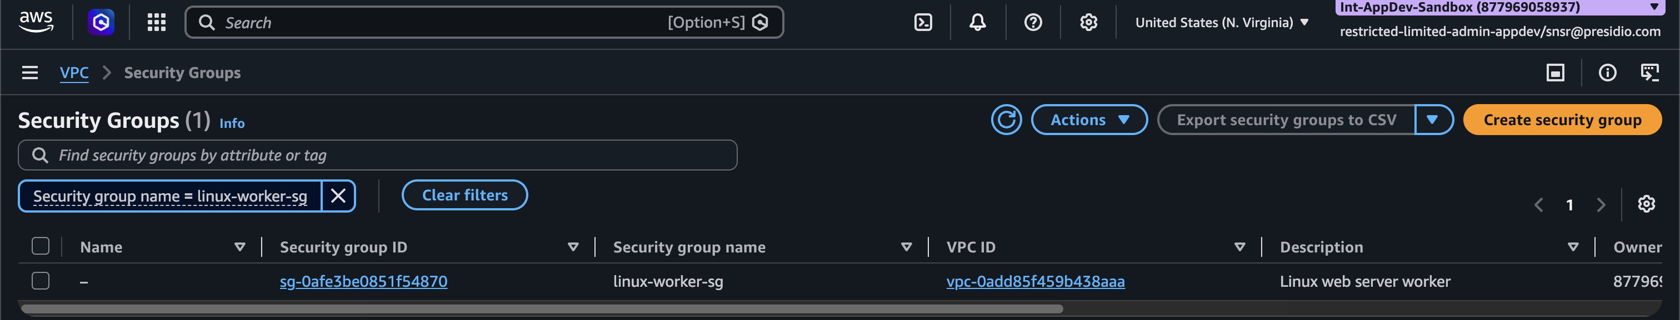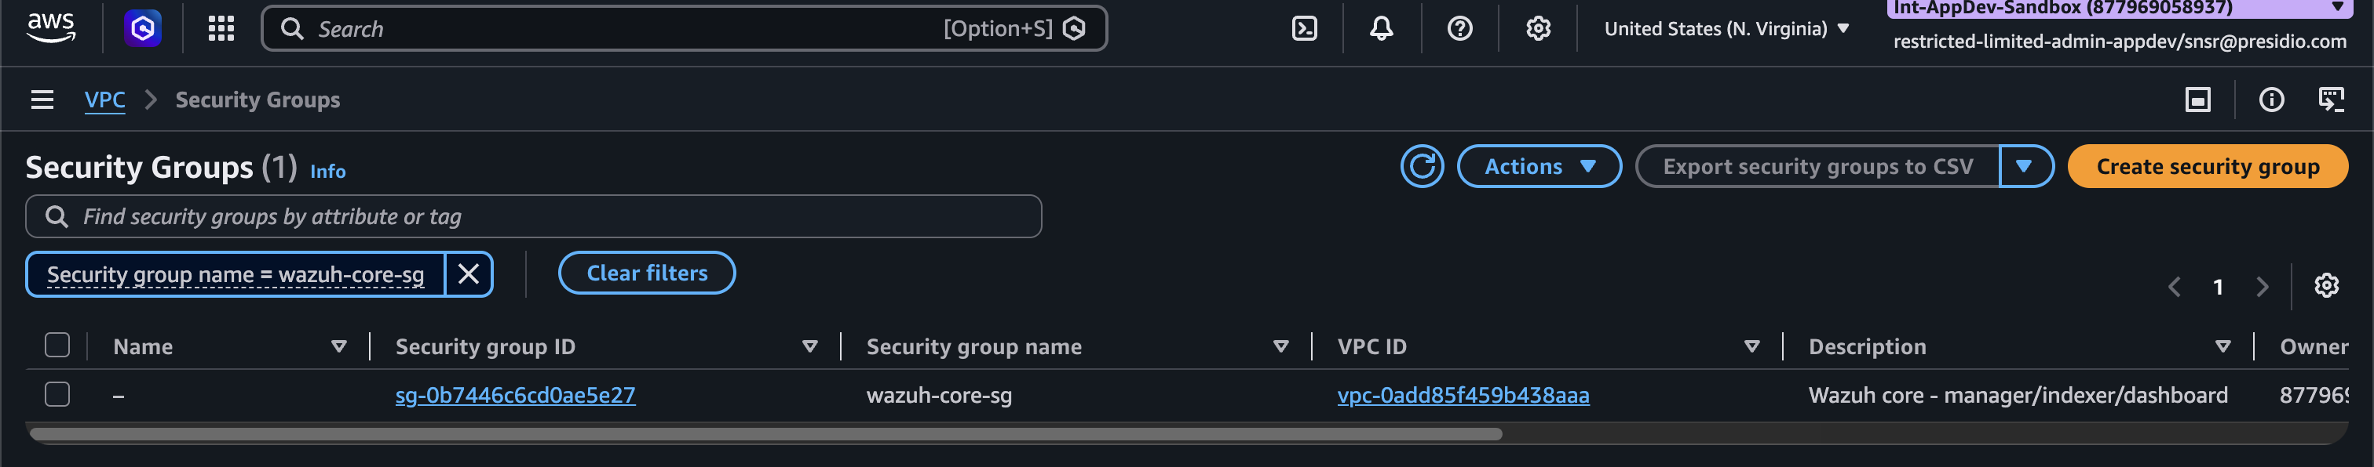VPC Security Groups Dashboard - Inbound rules scoped to specific IP/security-group referencesno 0.0.0.0/0 exposure

Phase 1 - EC2 Provisioning
Objective: Stand up compute for the manager and one attack target.
Details: wazuh-manager (t3.large, Ubuntu 24.04) and linux-worker (t3.small, Ubuntu 24.04) launched and reachable.
Launched both:
- wazuh-manager - t3.large, since it's running the full Docker stack (manager + indexer + dashboard, pretty resource-hungry)
- linux-worker - t3.small, since it's just Apache + DVWA + one lightweight agent
Screenshot: 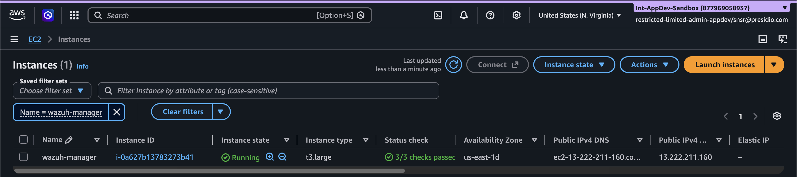
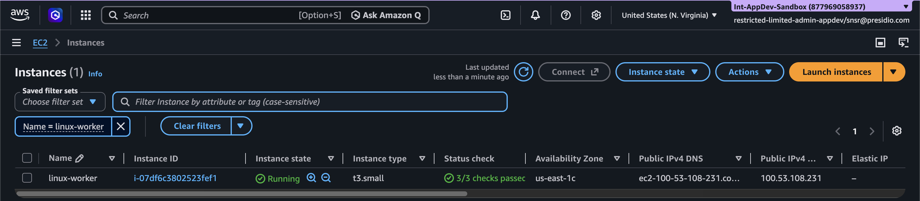EC2 Console → Instances view showing both running with their public IPs.

Phase 2 - Wazuh Manager Stack (Docker)
Objective: To deploy Wazuh's central components.
- Installed Docker on wazuh-manager, cloned the official wazuh-docker repo and I pinned it specifically to v4.14.7 because it’s always better to not choose the latest version and land in trouble.
- Generated the TLS certs for the indexer/manager/dashboard to talk to each other securely hit a bug here, the cert generator container threw a find: command not found error (its base image was missing that binary). But when I checked the output folder, all 12 expected cert files were there anyway, so it didn't actually break anything this time. So logged this in just in case it happens on a future rebuild.
- Brought the stack up with docker compose up -d, confirmed all 3 containers (wazuh.manager, wazuh.indexer, wazuh.dashboard) were healthy, and could log into the dashboard over HTTPS.
Result: 3 containers healthy (manager, indexer, dashboard); dashboard reachable over HTTPS.
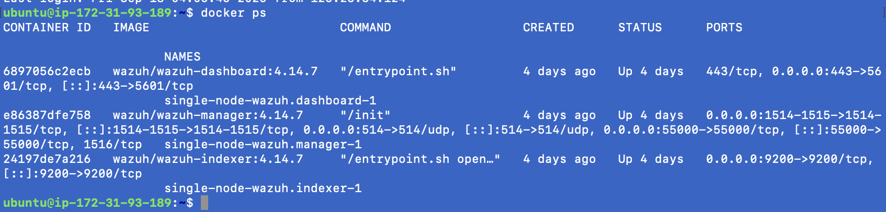
Terminal output of docker ps showing all 3 containers Up; browser screenshot of the Wazuh dashboard login pae.
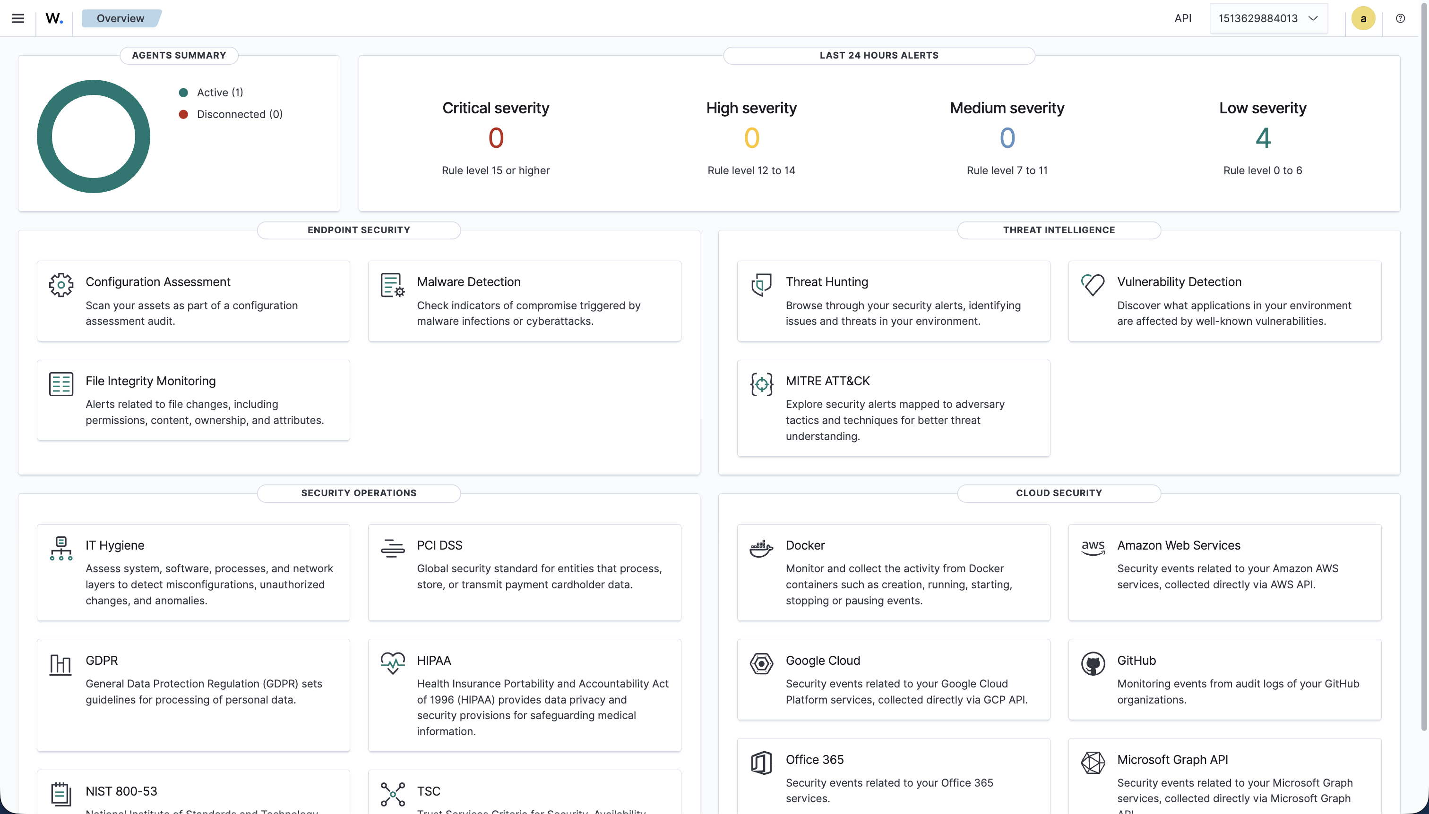
Wazuh Dashboard loaded

Phase 3 - DVWA Deployment (Attack Target)
Objective: Stand up a deliberately vulnerable web app to generate real attack traffic against.
Method: LAMP stack (Apache/PHP 8.3/MySQL) + DVWA, database configured, permissions set.
- Built a basic LAMP stack (Apache, PHP 8.3, MySQL) on linux-worker, cloned DVWA, pointed its config at the database I set up, and fixed file permissions (had to make the uploads folder world-writable and enable allow_url_include in php.ini, both of which DVWA specifically needs to actually be vulnerable which is the whole point).
- Logged in as admin, set security level to Low so the vulnerabilities are actually exploitable for testing.
Result: DVWA reachable and logged in as admin
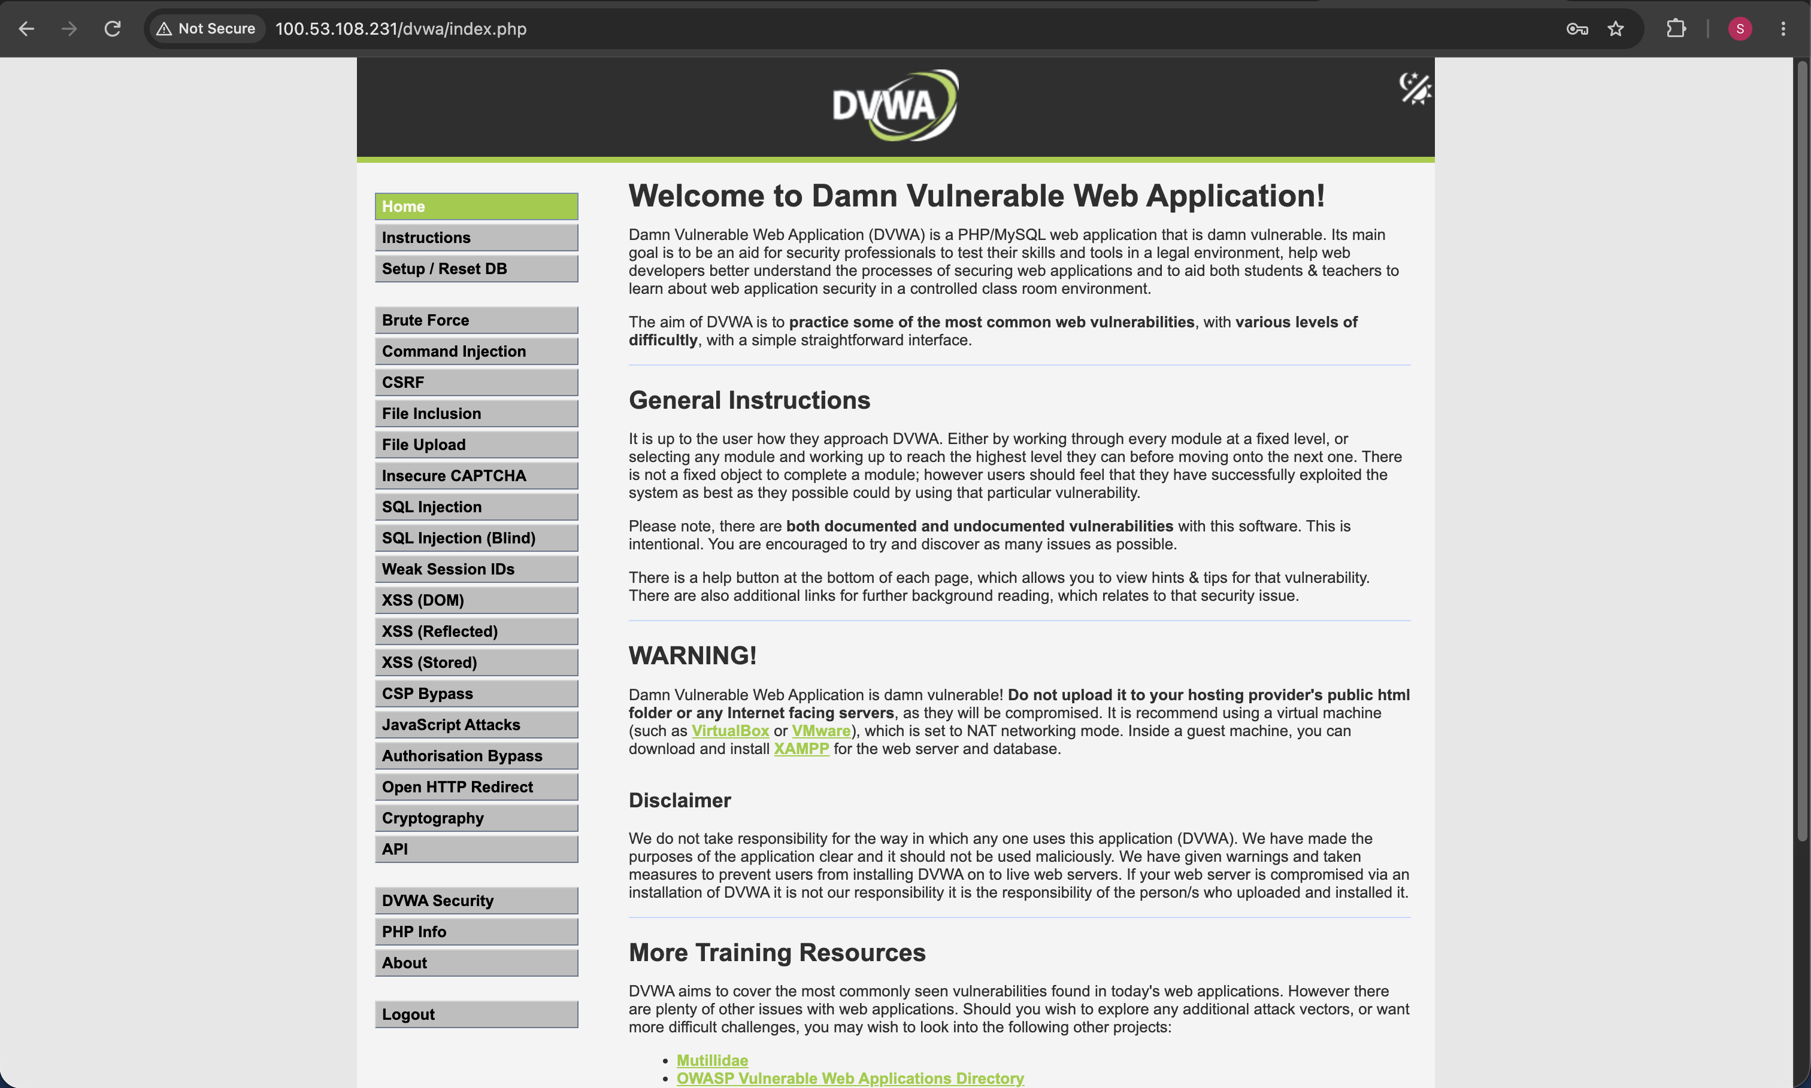
Browser screenshot of DVWA home page while logged in

Phase 4 - Wazuh Agent Installation & Enrollment
Objective: Get linux-worker's logs flowing into the manager.
Method: Installed the Wazuh agent package, enrolled it against the manager, started the service.
Agent enrollment on linux-worker just... worked. Installed the package, registered it against the manager, started the service, and it showed up Active in the dashboard right away - no permission errors, no config errors.
Result: Agent shows Active in the dashboard.
Wazuh Dashboard → Agents view showing ip-172-31-12-45 as Active.
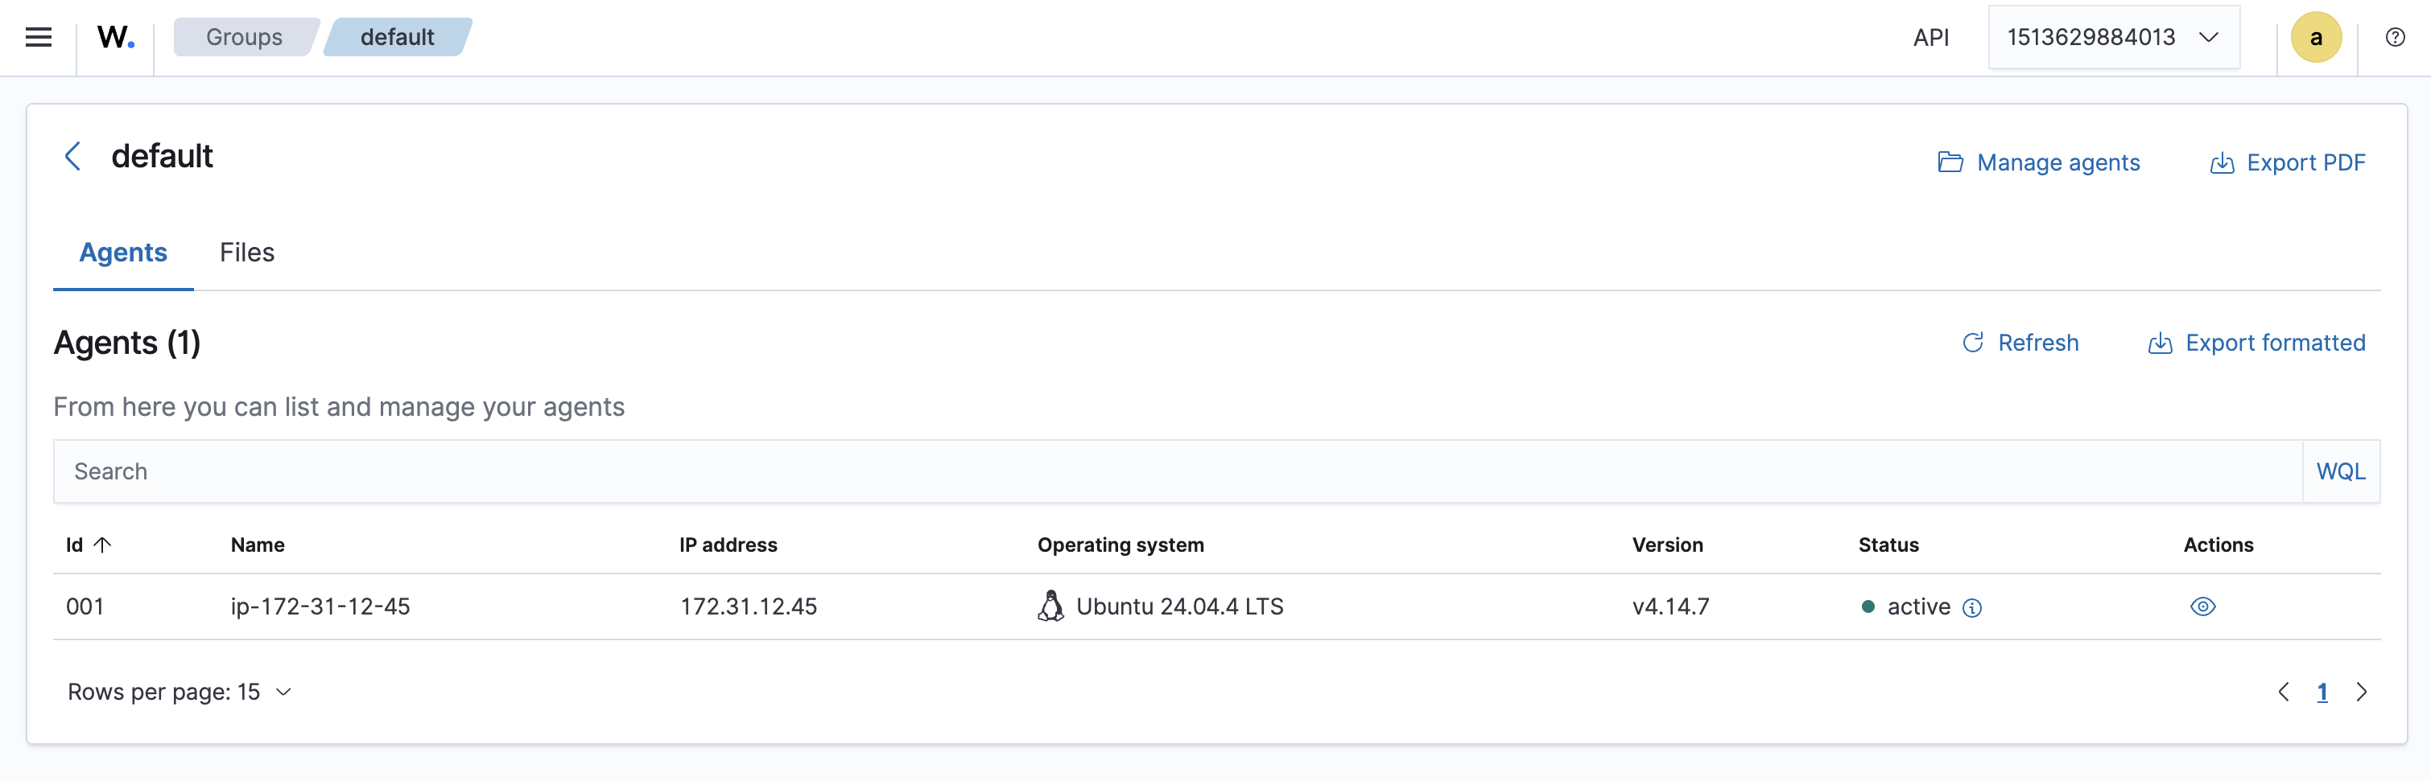
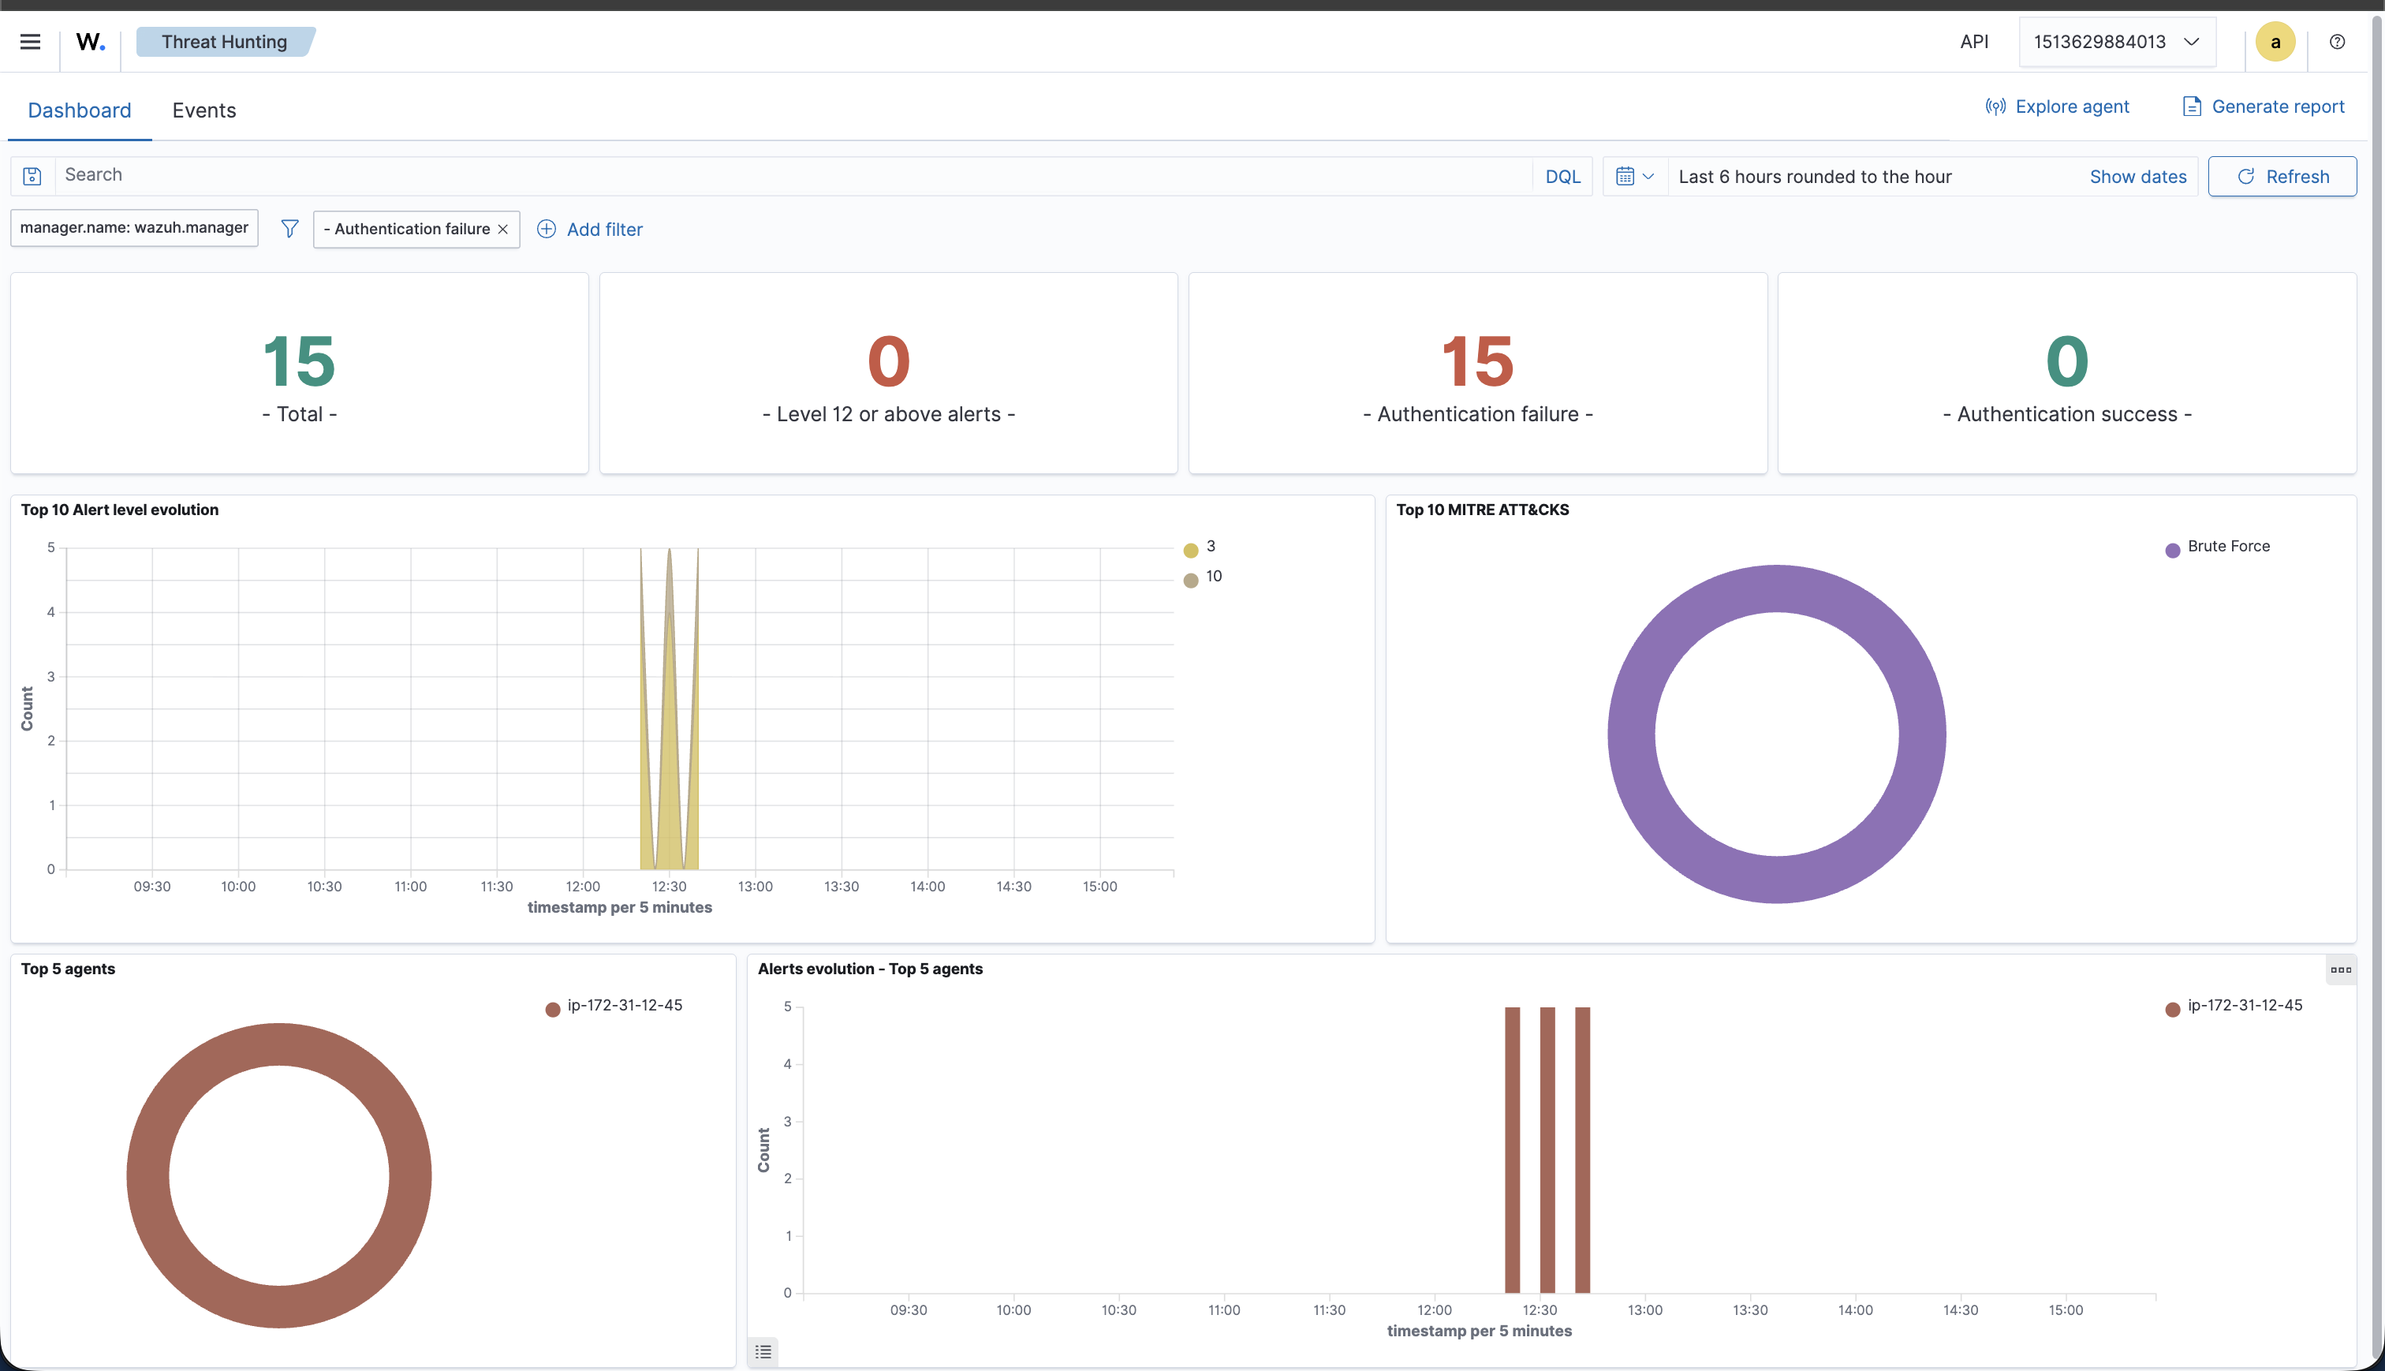

Phase 5a - Brute-Force Detection Rule
Objective: Detect repeated failed logins against DVWA's login form; map to MITRE T1110.
Method: Wrote atomic rule 100002 (matches any hit on /dvwa/vulnerabilities/brute/) and correlation rule 100003 (escalates to level 10 when the same source IP triggers 100002 five times within 120 seconds). Verified first via wazuh-logtest, then with real attack traffic.
- Wrote two rules: an atomic one (100002, level 3) that just flags any hit to DVWA's brute-force login page, and a correlation rule (100003, level 10) that escalates when the SAME source IP triggers that atomic rule 5 times within 120 seconds - because one wrong password isn't an attack, but 5 rapid ones from the same IP is.
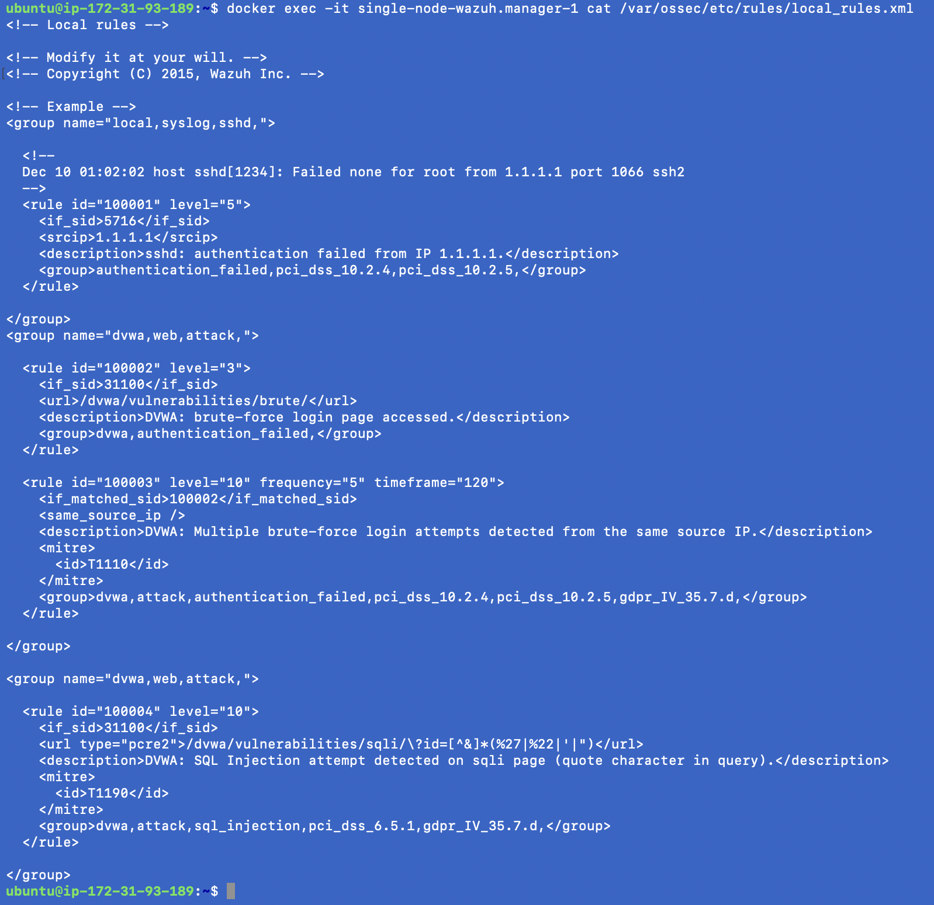
rule 100002 and 100003 written in local_rules.xml
- Tested it with wazuh-logtest first using a fake log line, worked fine in simulation.
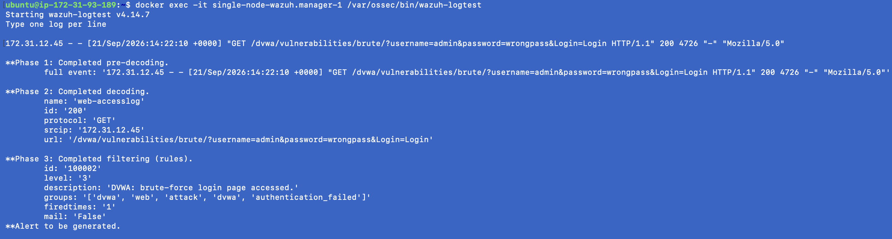
- One debugging note was that (my own stupidity), initial real-traffic test showed zero alerts root cause was an expired DVWA session, so "attack" requests were redirected to the login page (HTTP 302) instead of reaching the actual page. Had to fix by re-authenticating and navigating via the sidebar.
Result: Verified- 5 real failed logins produced 4× rule 100002 (level 3) then 1× rule 100003 (level 10, MITRE T1110, PCI DSS 10.2.4/10.2.5, GDPR IV_35.7.d).

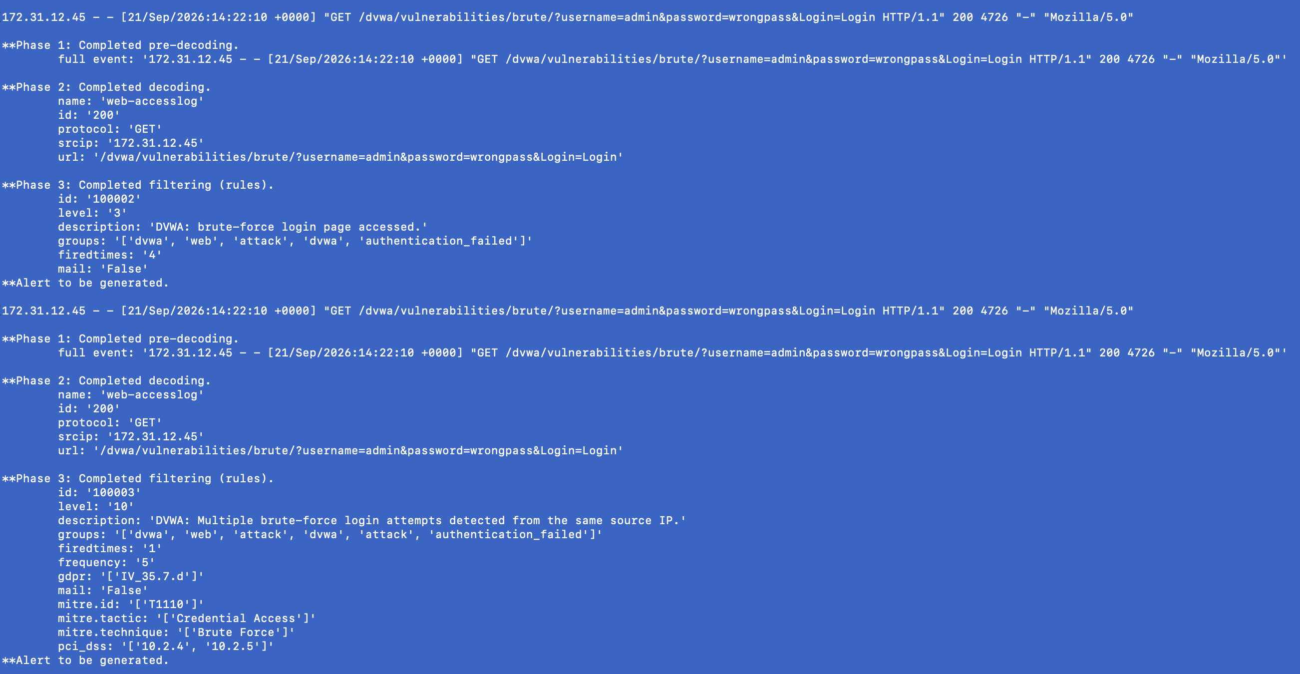Terminal showing the live alerts.json tail with rule 100003 firing as soon as the Apache log line hit the 5th time
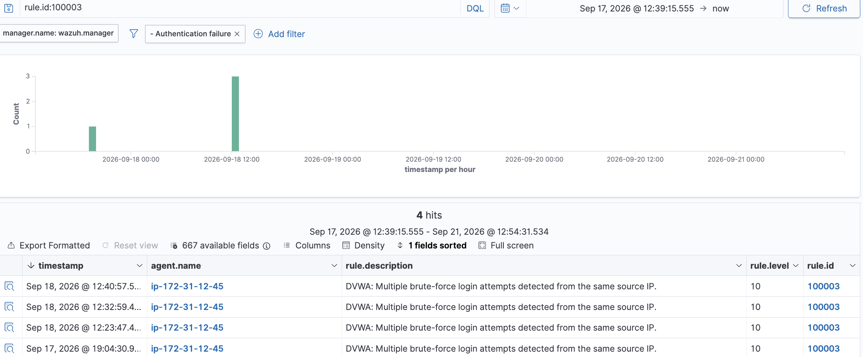

Threat Hunting/Discover showing the same alert

Phase 5b - SQL Injection Detection Rule
Objective: Detect SQL injection attempts against DVWA's SQLi page; map to MITRE T1190.
Wrote rule 100004 to catch a quote character showing up in the id parameter on DVWA's SQLi page since typing a single ' is the classic first move in SQLi.
I came across two bugs not critical but quite the annoying ones:
- My first version of the rule fired on literally everything, even a completely harmless id=1 with no quote at all. Turned out my regex was matching against the entire raw log line instead of just the URL and every Apache log line naturally has quote characters in it anyway so it was basically matching all the time for the wrong reason. Fixed by scoping the regex specifically to the URL field, and matching for the encoded form of a quote (%27/%22) since browsers automatically percent-encode special characters before sending them.
- Once that was fixed, actually submitting a real quote character crashed DVWA with a generic HTTP 500 error instead of showing query was broken message. Turns out this is a compatibility issue DVWA is old and expects an older, more forgiving version of PHP's mysqli behavior, but PHP 8.1+ changed it to throw hard exceptions on query errors by default. Fixed with one line (mysqli_report(MYSQLI_REPORT_OFF);) in DVWA's config to restore the old behavior.
Also ran into a completely separate bug while fixing all this: every time I edited the rules file by copying it out of the Docker container, editing it, and copying it back in, it landed with the wrong file owner inside the container which was causing Wazuh to throw "Permission denied" and silently fail to load my changes. Had to chown it back to the internal wazuh user every single time after a docker cp. Once both bugs were actually fixed, tested it properly: plain id=1 → no alert (correct), 1' OR '1'='1 → dumps every user in the table and fires the alert at level 10 with the MITRE T1190 tag.
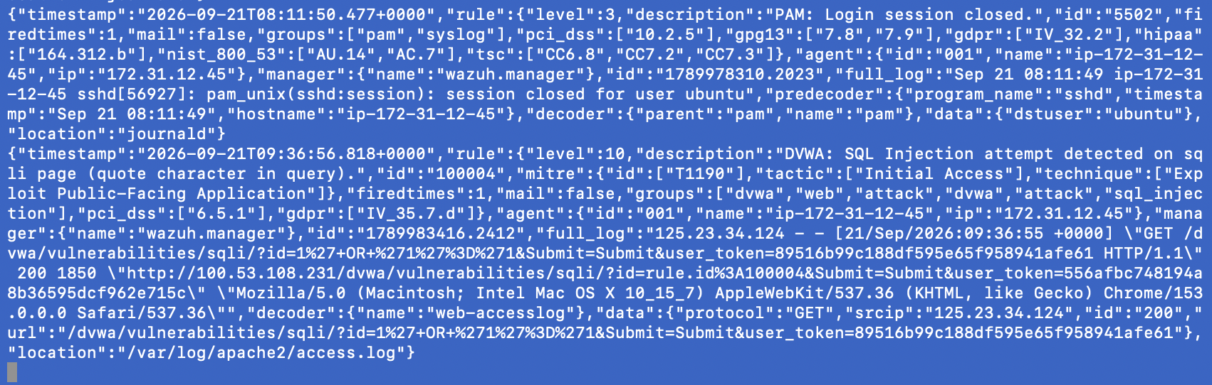Real payload awas sent (1' OR '1'='1 ) rule 100004 to appears
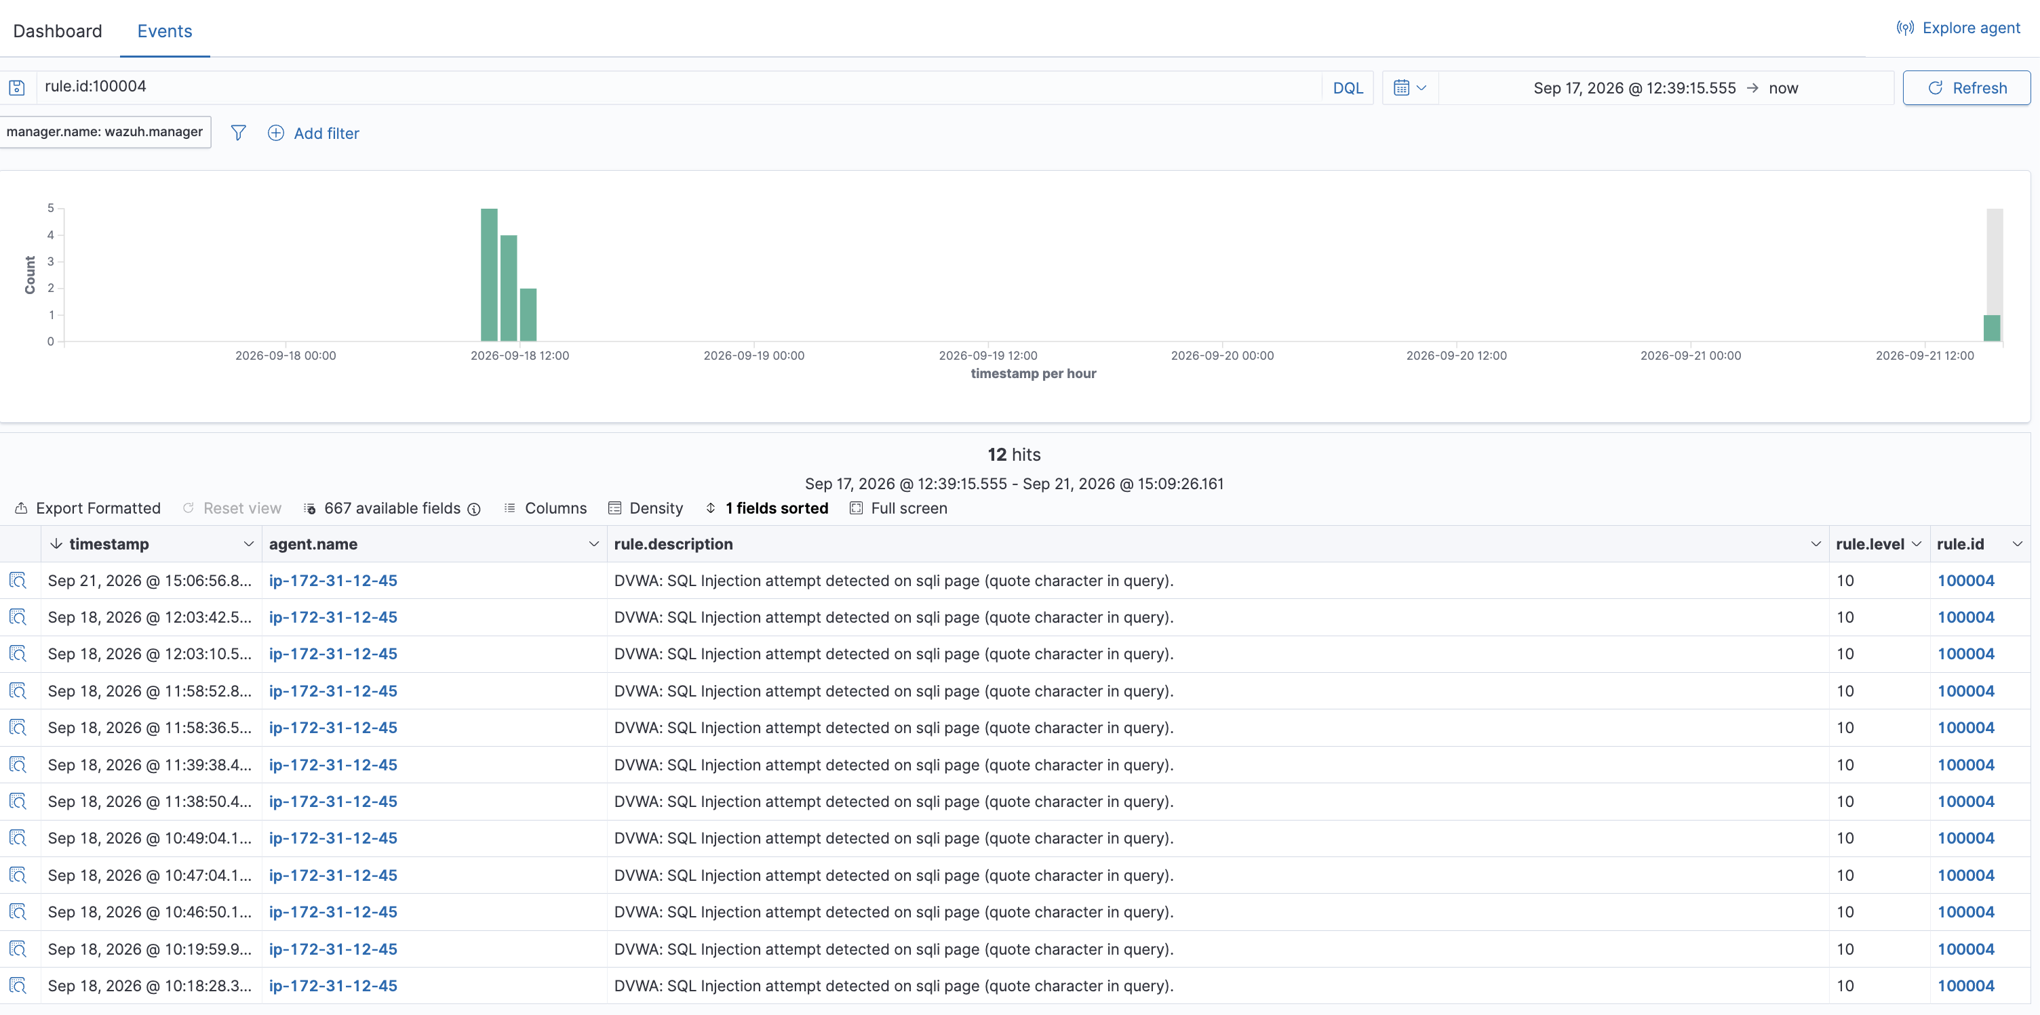
Phase 6 - Alerting (Slack + Email)
Objective: Route high-severity rule matches (level ≥7) to two independent external channels so a human doesn't have to be watching the dashboard.
Result: Verified a live SQL injection attack against DVWA produced both a Slack message and an email within seconds, each showing the correct rule, level, agent, and raw log data.
Slack: Wazuh already ships a built-in Slack integration, just needs a webhook URL. Spent a bit going in circles because I was looking for "Incoming Webhooks" inside the regular Slack app itself turns out that's a completely separate website (api.slack.com/apps), not something inside Slack's normal UI at all.
DO NOT EXPOSE THE WEBHOOR URL. Regenerate the webhook if so and switch to a safer way of double-checking the config (redacting the secret with sed before ever showing it to anyone).
Once that was sorted, added the <integration> block to ossec.conf with a level-7 threshold (so it only pages for the serious escalated stuff, not every single wrong password), and got real Slack messages firing off real attacks.
Email: Wazuh's built-in email system can't actually log into Gmail. I wrote a small custom Python script that logs in properly with an app password over STARTTLS and sends the alert as an email, and told Wazuh to run that script whenever an alert crosses the threshold (same mechanism Wazuh uses internally for Slack, just my own script instead of theirs). No issues as such I came across, this was pretty smooth.
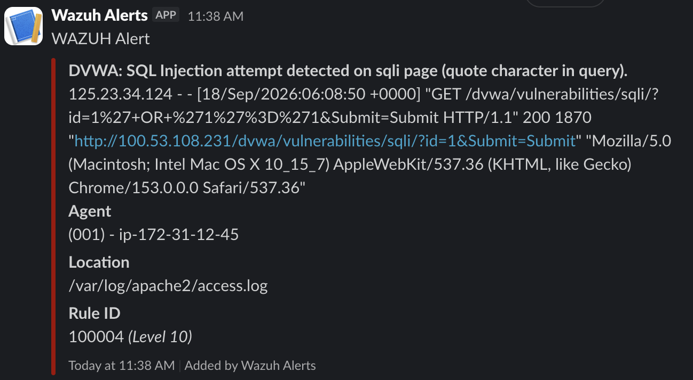
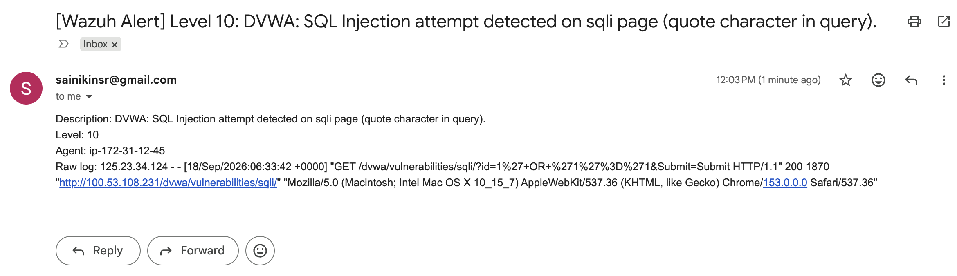
Phase 7 - Active Response (SOAR)
Objective: Automatically contain a brute-force attacker without human intervention, then self-reverse after a bounded window.
So there’s Wazuh's built-in firewall-drop response to fire whenever the escalated brute-force rule (100003) triggers, along with a 120-second auto-expiry so it doesn't lock me out forever.
First attempt failed immediately with Invalid active response location: 'defined' turns out the actual correct keyword is local, which just means "run this on whichever agent raised the alert," not "the manager, so had to get help from Claude for this one.
Tested it for real 3 separate times, and every single time the active-responses.log showed the block getting applied and then automatically removed almost exactly 2 mins later matching the timeout perfectly. On the third test, my own SSH session into linux-worker literally died the instant the block kicked in, since the firewall drop blocks all traffic from that IP, not just the DVWA port. Wasn't planned, but honestly better proof than anything I was trying to capture on purpose showed the block is real and total, not just something Wazuh claims happened.
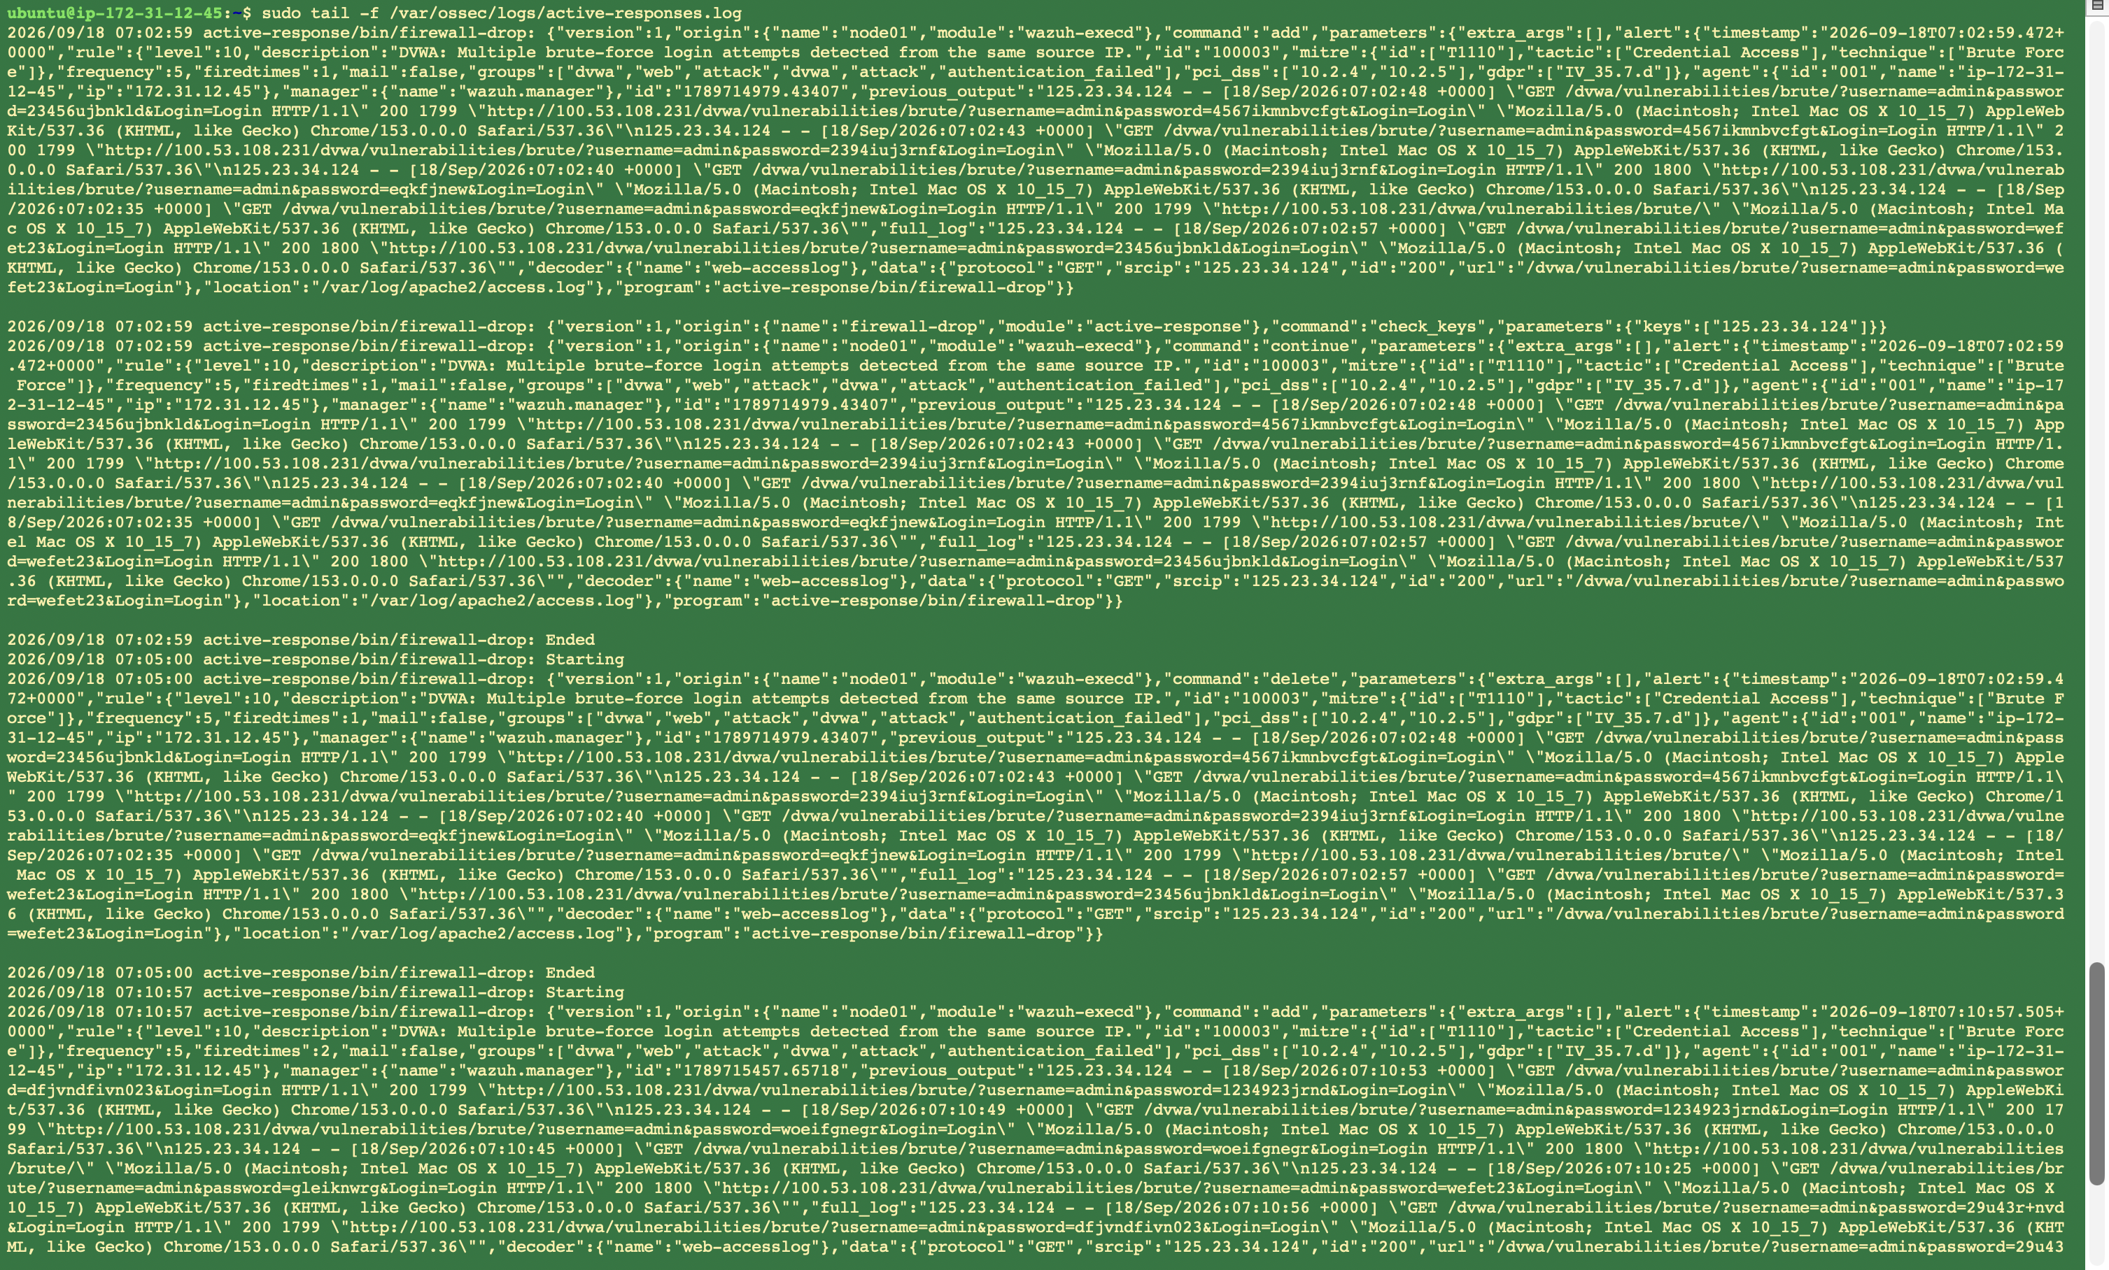 The active-responses.log excerpt showing one full add→delete cycle with timestamps.
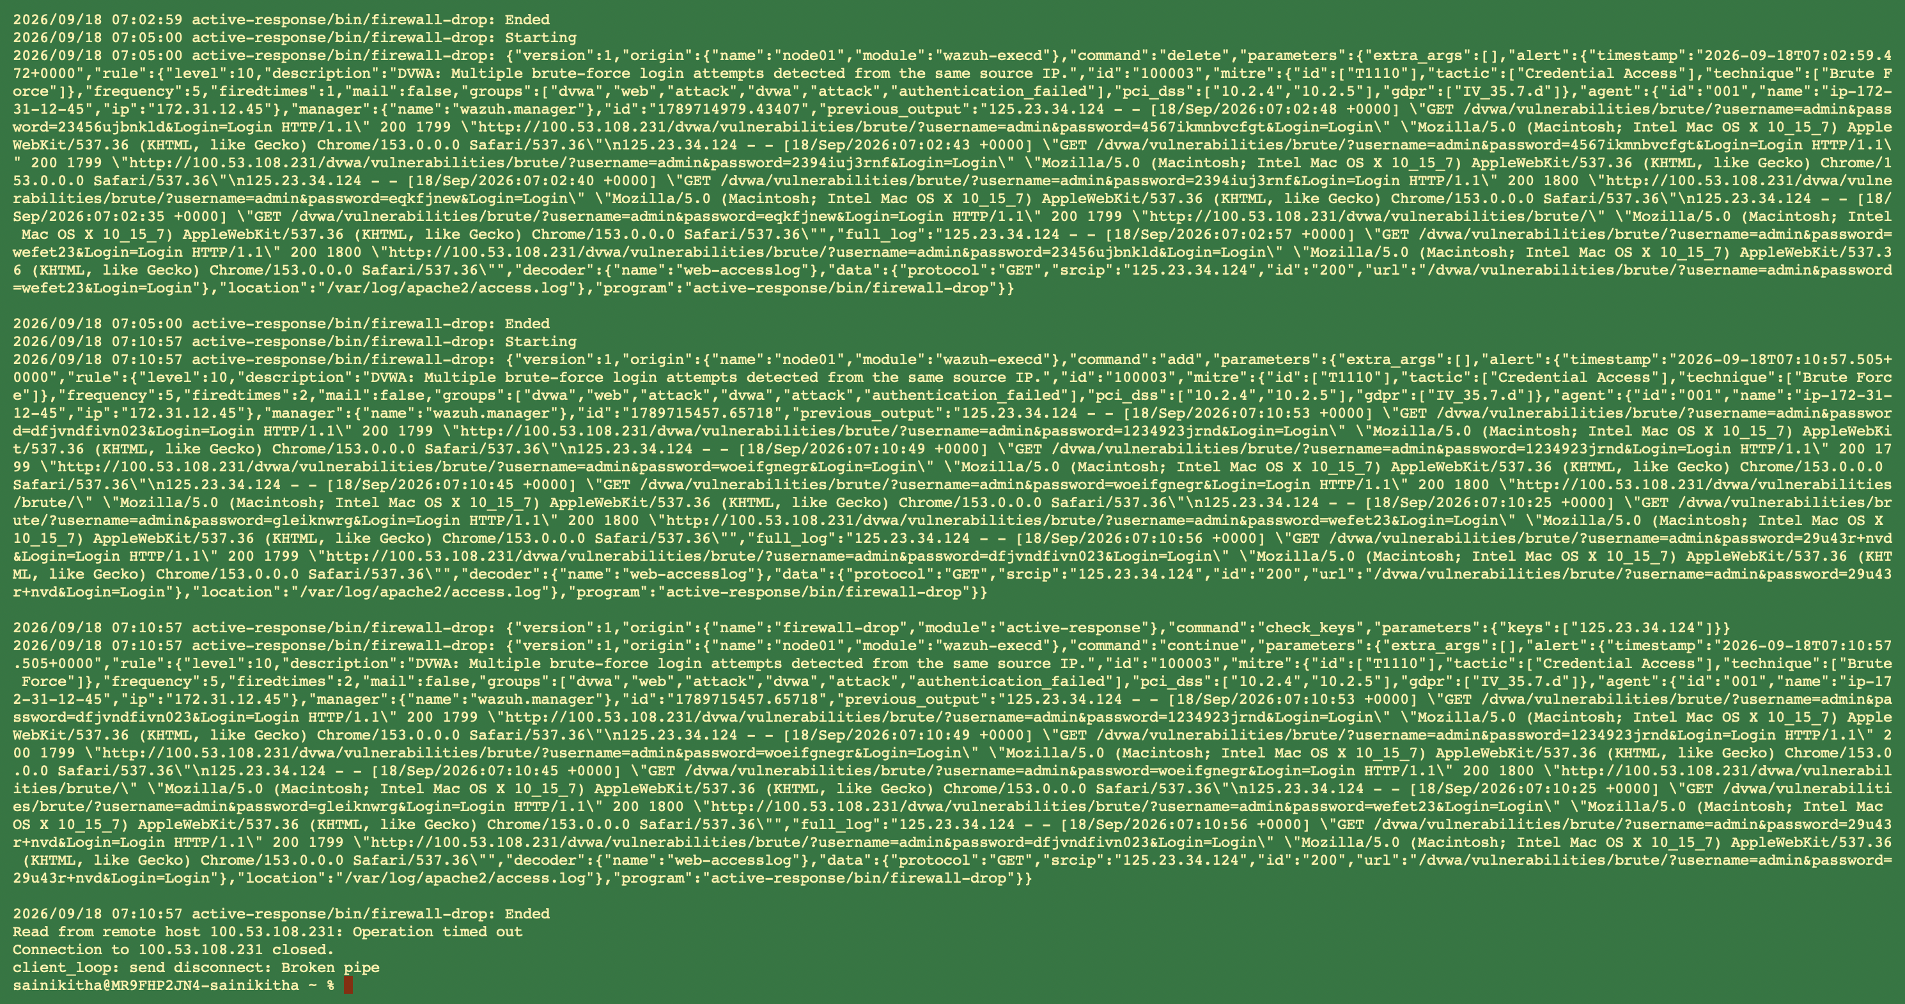 active response working exactly as designed
The firewall-drop script blocks all traffic from the offending IP at the network level, not just port 80/HTTP, so the moment 125.23.34.124 got blocked, it took down my SSH session (port 22) along with my DVWA access, because both were coming from the same source IP
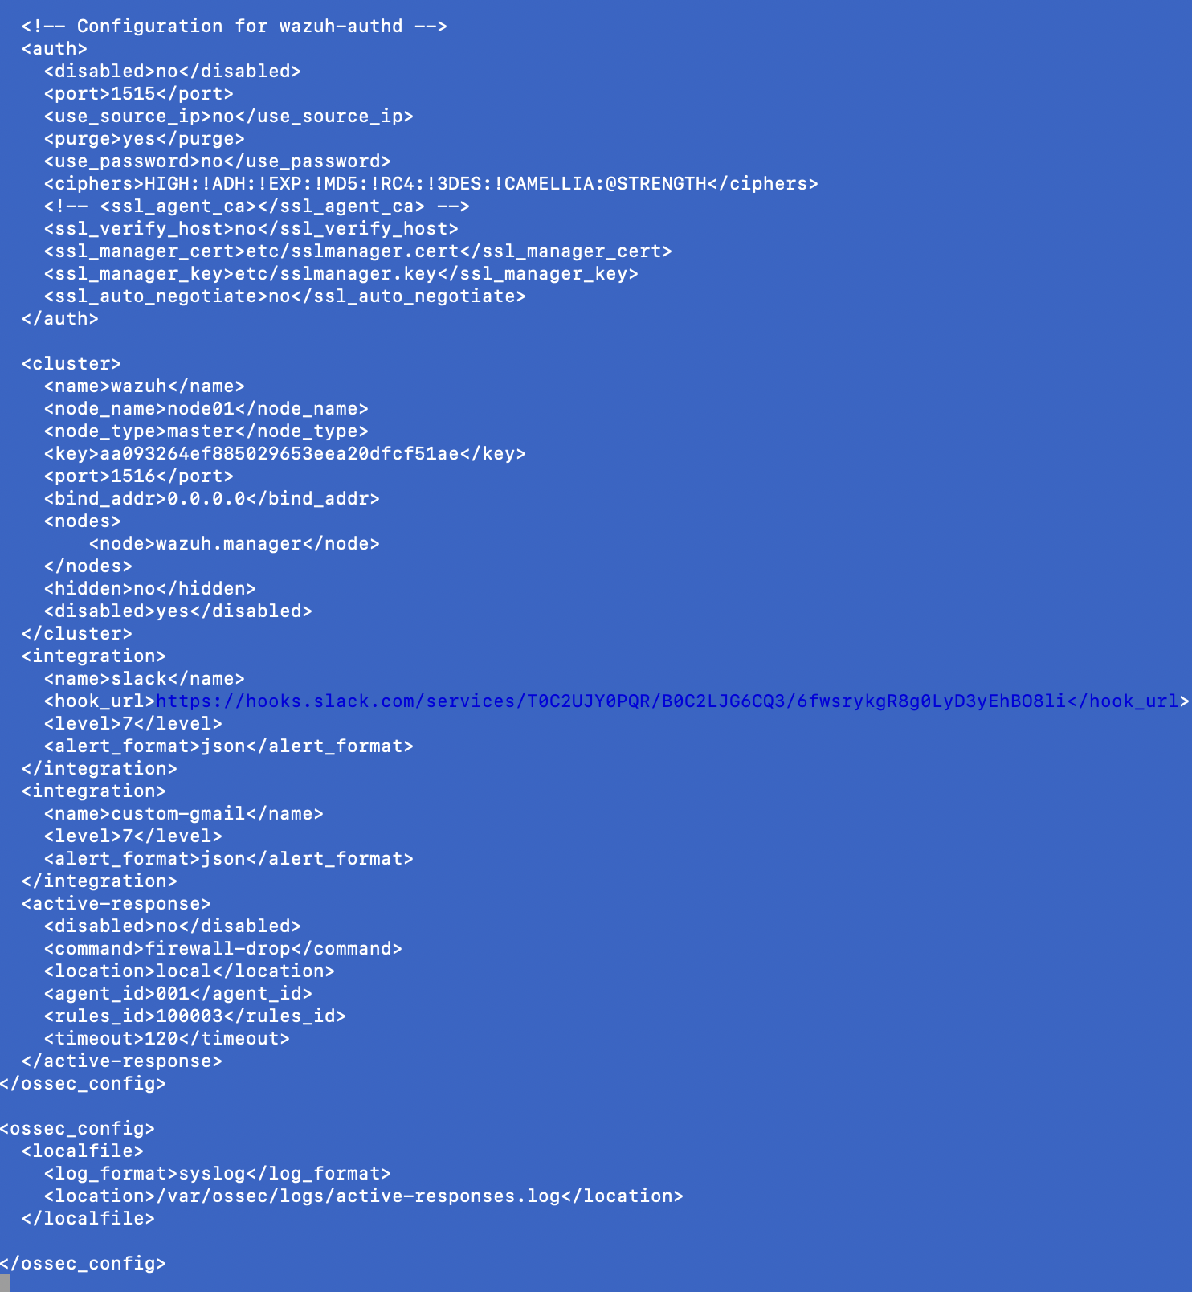
The <active-response> block in ossec.conf

Phase 8 - Building the dashboard
Put together a custom dashboard with two panels: a table showing hit counts for each of my custom rules (filtered to just the dvwa rule group - 12 brute-force hits, 11 SQLi hits, 3 escalated brute-force alerts), and a pie chart showing all alerts broken down by severity level.
Spent a bit of time just hunting for the right menu - the "Visualize" and "Dashboard" apps live under a section called Explore, not under "Dashboard Management" like I first assumed. Also had a moment where every panel showed zero results, which turned out to be because the time range picker had somehow gotten set to a single exact instant instead of an actual range (start time = end time = same millisecond, so obviously nothing matched). And the field name for rule descriptions turned out to just be rule.description, not rule.description.keyword like I expected - the index apparently already maps it as an exact-match field without needing that suffix.
Once all that was sorted, both panels rendered exactly as expected - real numbers matching everything we'd actually tested.
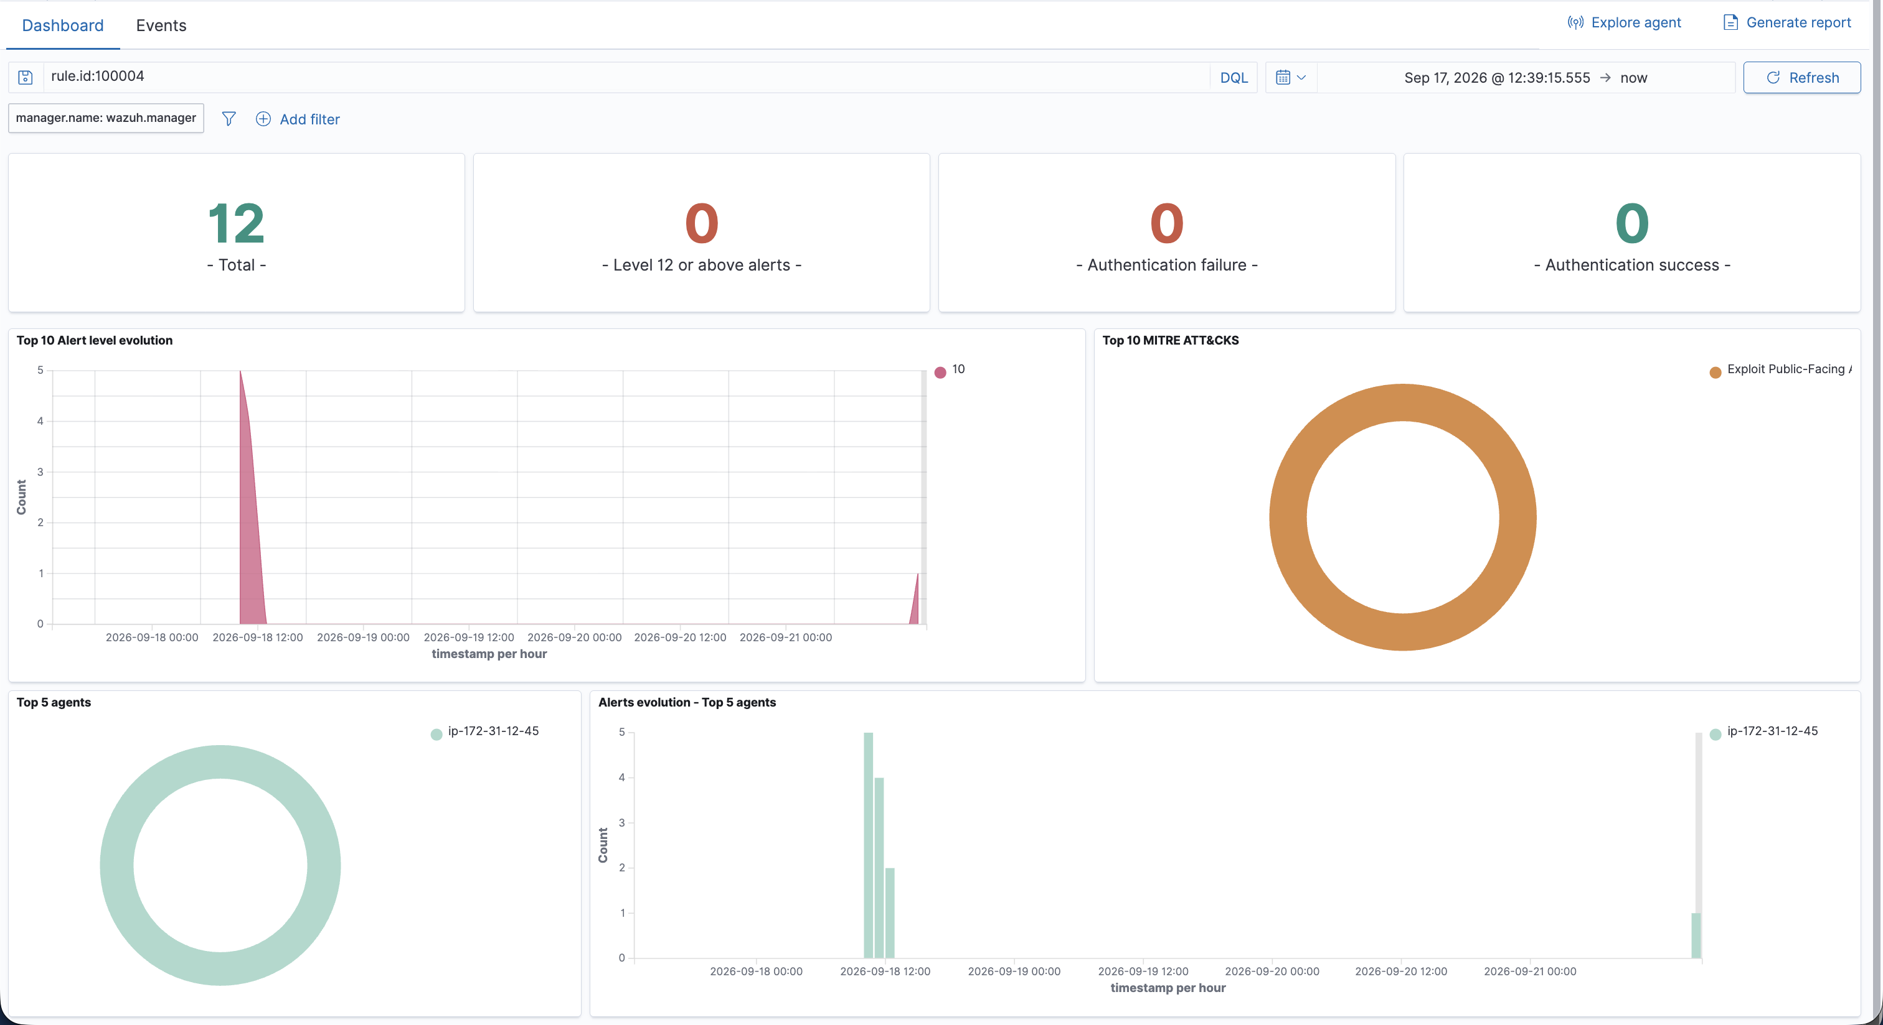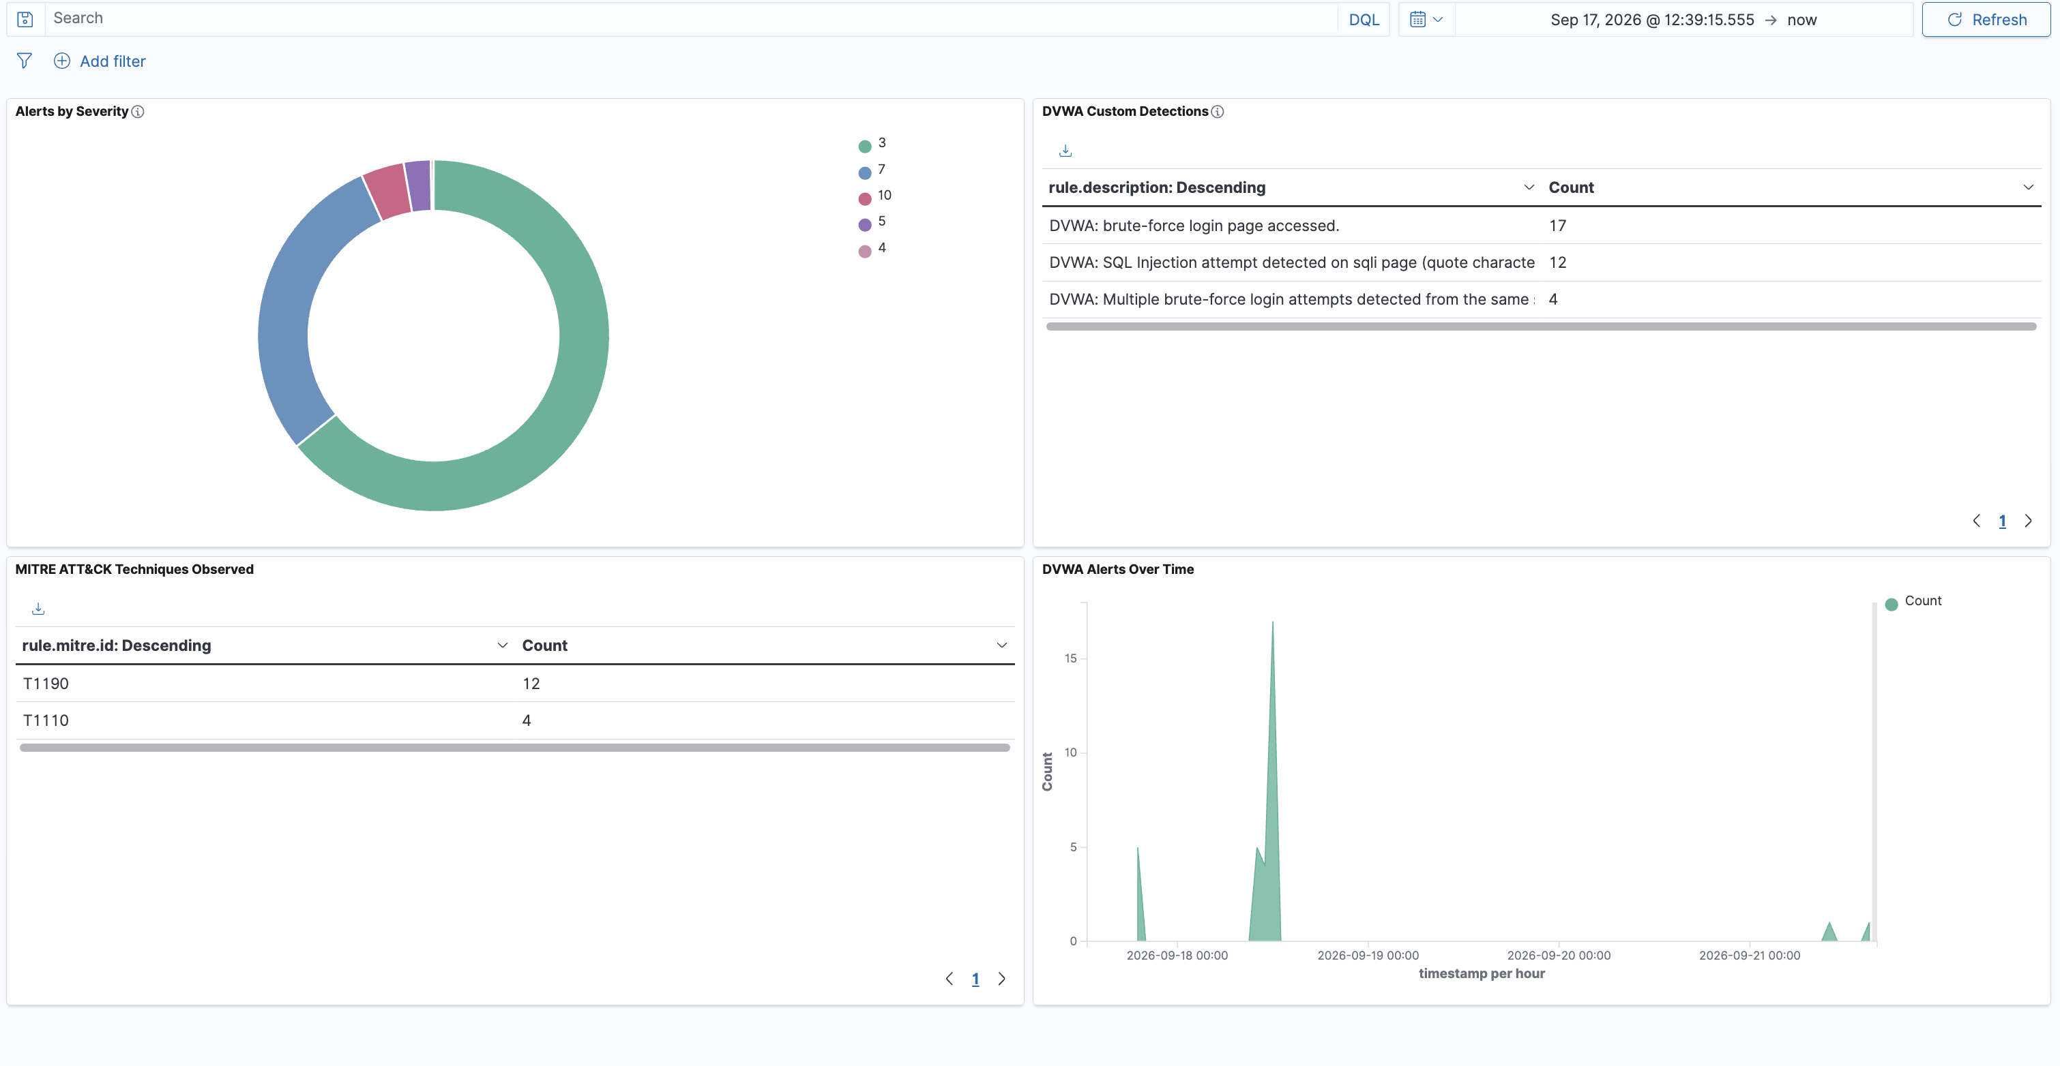
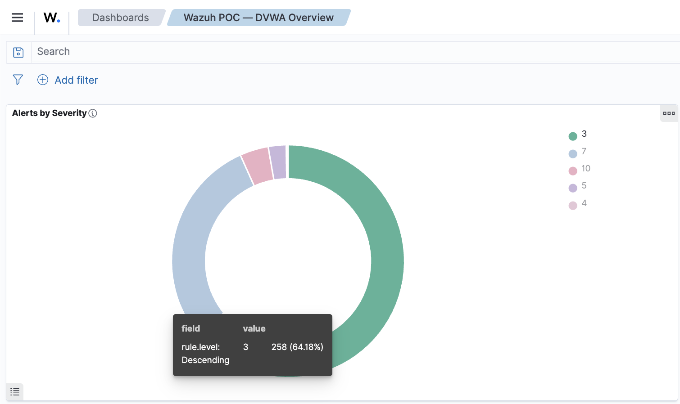
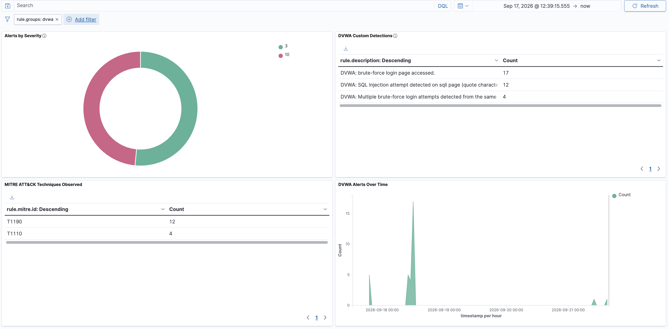Dashboard filtered to rule.groups: dvwa, isolating just the custom detections built in this POC — confirms the panels are querying live indexed data, not static counts.
Confirmed via aws ec2 describe-security-groups that nothing anywhere is open to 0.0.0.0/0. Everything human-facing (80/22/443) is locked to my own IP specifically, and the internal agent-to-manager ports are locked via security-group references instead of any open IP range. So nothing was ever actually exposed to the internet, even though the instances themselves have public IPs.

Phase 9 — Windows Agent Installation & Custom Detection Rule
- Objective: Extend coverage beyond Linux/web attacks by enrolling a Windows endpoint and detecting a Windows-specific persistence technique (MITRE T1136 — new local account creation).
- Method: Launched a Windows Server 2022 EC2 instance, connected via AWS Systems Manager Fleet Manager (browser-based RDP, no local client needed), installed and enrolled the Wazuh agent, enabled Windows auditing for account management events, wrote a custom rule (100005) to catch Event ID 4720.
- Debugging notes :
  - First hurdle was just getting into the Windows box at all. My first instinct was the standard Microsoft Remote Desktop client, but that's App Store only now, and due to an issue with my Apple ID errors on verification so not worth the time. Tried the open-source route instead (FreeRDP via Homebrew), which worked for install but then needed XQuartz (an X11 display server) just to open a window, and that needed a logout/login cycle to fully register. So, I gave up on the local-client approach entirely and used AWS Systems Manager's Fleet Manager instead - gives you a full RDP session right inside the browser tab, no local software needed at all. Should've started there.
  - I also noticed my Mac's public IP had changed mid-session from a network reconnect earlier in the day - meaning the security group I was about to build would've been locked to a stale IP I’m thinking, so had to catch that and update the RDP rule to match my actual current IP before I could even get in.
  - Once I was finally on the Windows desktop, agent install itself was easy. Switched to the manager's private IP for both enrollment and ongoing communication, and it worked immediately.
  - Enabled Windows auditing for account management events (off by default), wrote a custom rule matching Event ID 4720, restarted the manager, then actually created a user (net user hacker ... /add) to trigger it for real. Rule fired clean- level 10, MITRE T1136 was tagged, agent showing Active - confirmed straight from alerts.json.
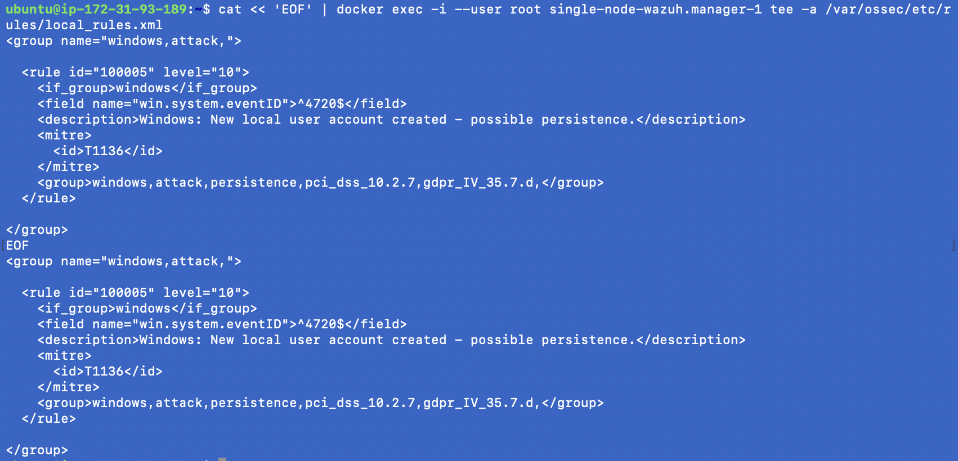
- Result: Agent 002 (EC2AMAZ-6FQRTQP) enrolled and Active; real test (net user hacker ... /add) fired rule 100005 at level 10 with MITRE T1136 tagged, confirmed via alerts.json.
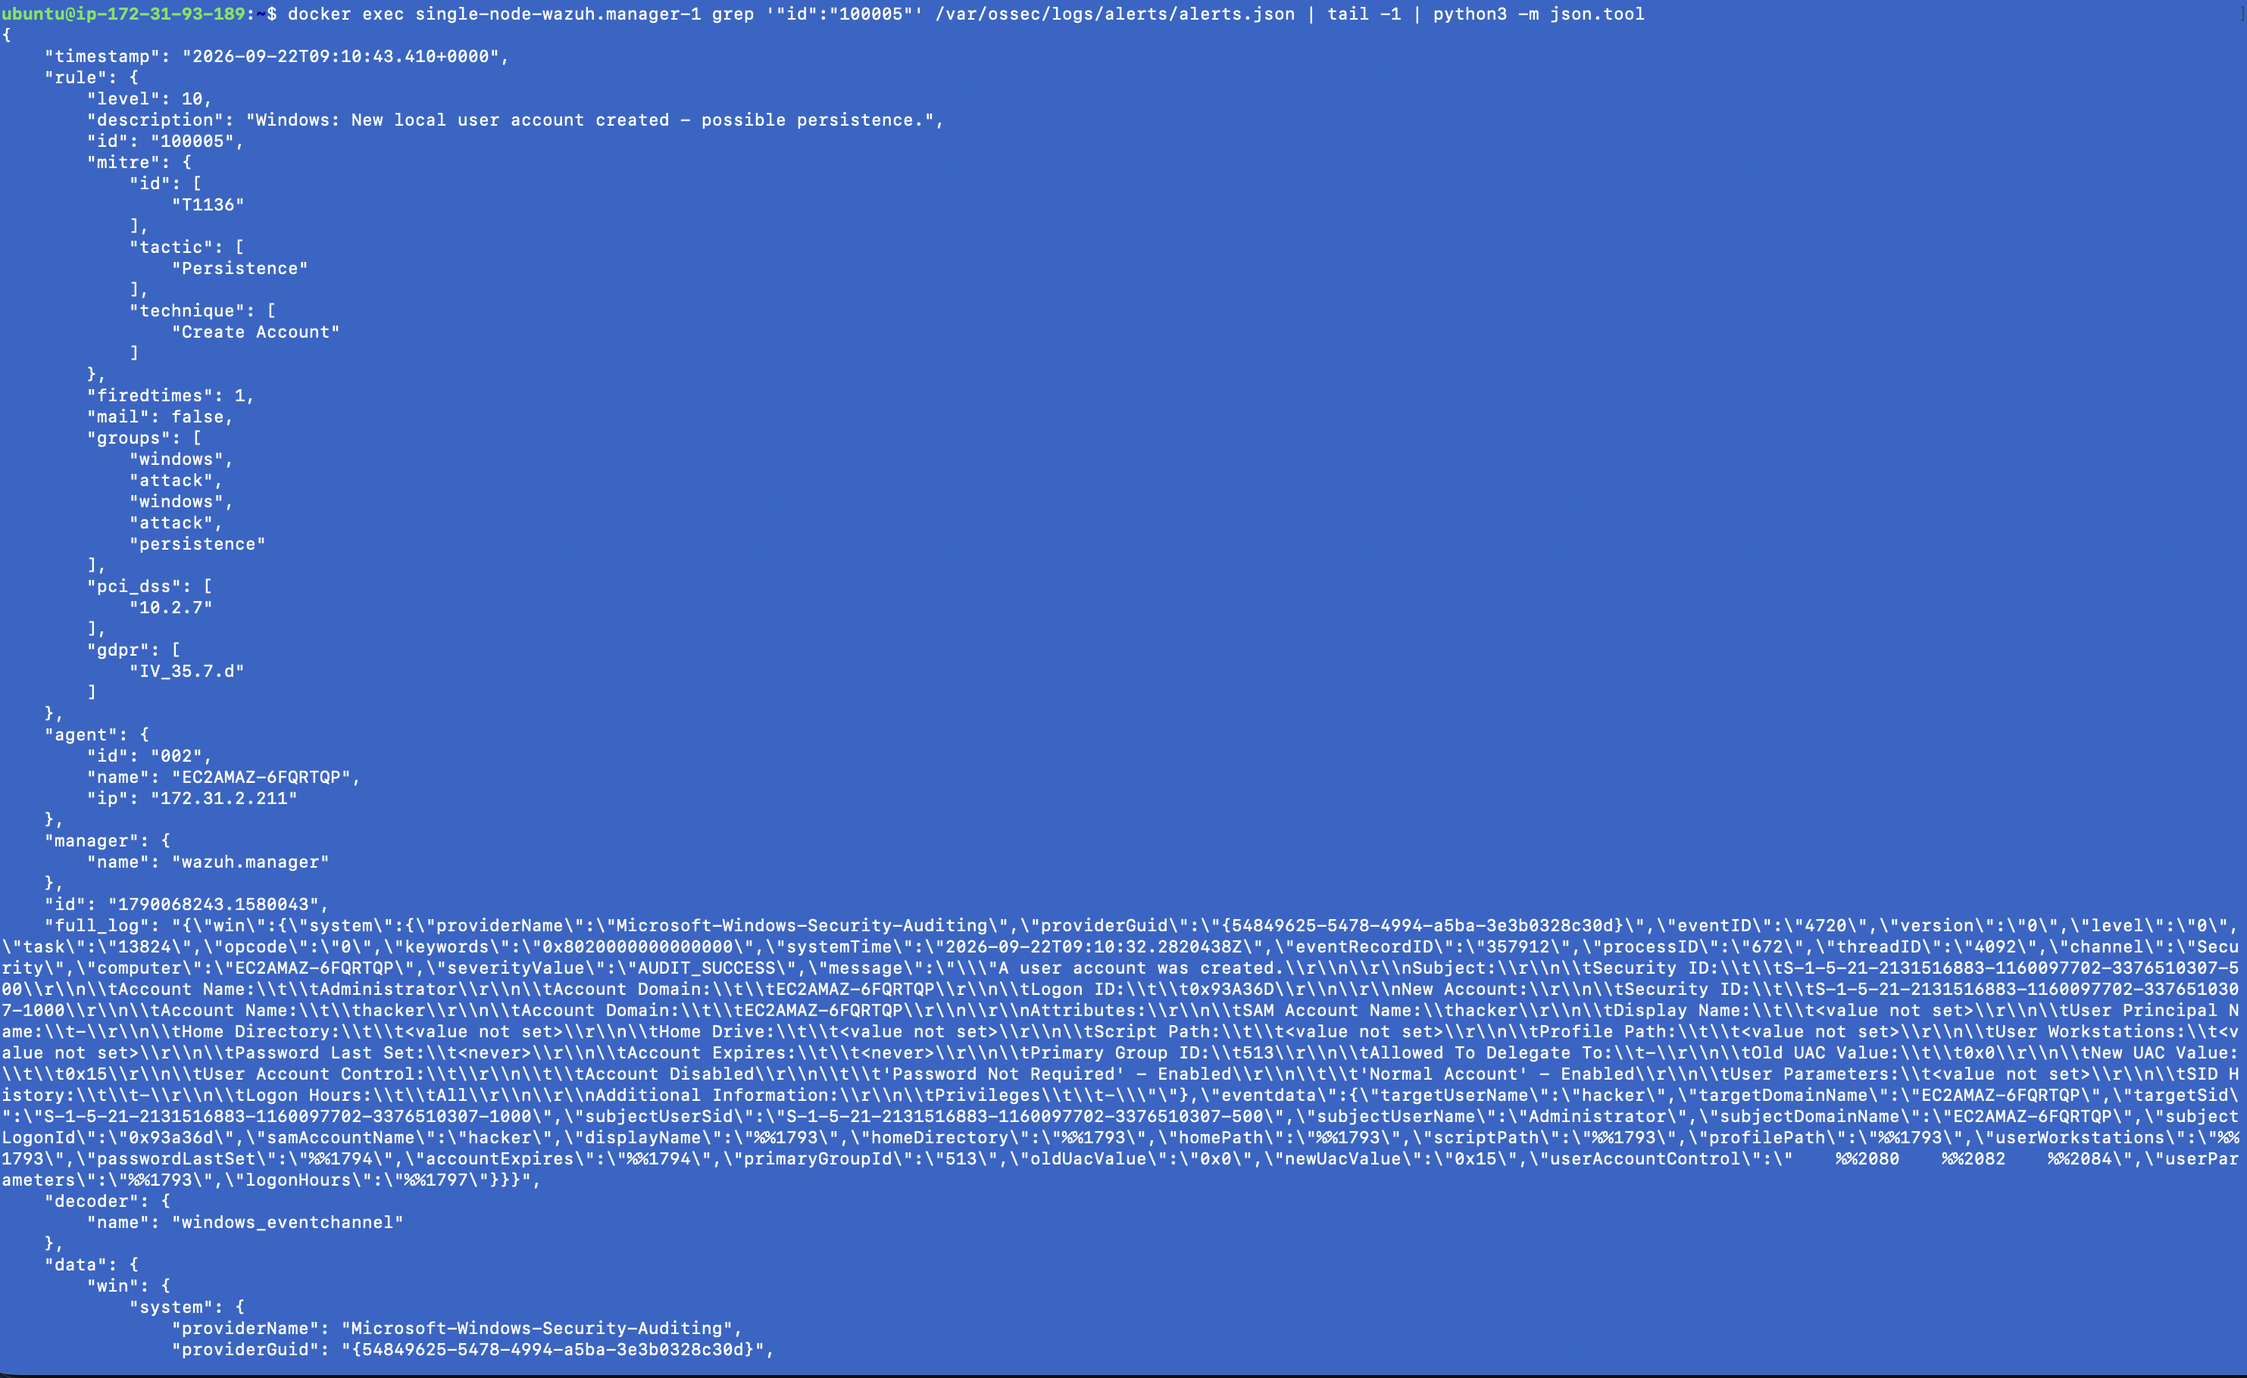

Phase 10 — Post-Review Gap Remediation

After the initial live demo, a round of reviewer questions surfaced real gaps rather than presentation gaps — mainly around distinguishing genuine attacks from noise, and making the system fully operable from the dashboard rather than the terminal. This section documents each gap that was revisited, what was actually wrong, what changed, and live proof each fix works.

10.1 — Windows Persistence: Distinguishing Approved vs. Unexpected Accounts
The gap: The original rule (100005) fired at high severity on any new local account creation, with no way to tell a routine, approved provisioning action (e.g. IT creating a service account) from an actual attacker planting a backdoor account. In a real environment this would page the team for legitimate admin work every time, training people to ignore the alert — the exact failure mode that causes real incidents to get missed.
The fix: Split the single rule into two: rule 100005 (level 3, informational) now logs any account creation whose name matches a known-approved allow-list (e.g. it-admin, svc-provision). Rule 100006 (level 10, MITRE T1136) fires only when the created account name does NOT match that allow-list — i.e., an unexpected account.
Verified: Creating an allow-listed account (it-admin) produced only the level-3 log entry, no page. Creating a non-allow-listed account (hacker) correctly escalated to level 10 with the MITRE T1136 tag, and the alert captured both the account name and the account that created it.
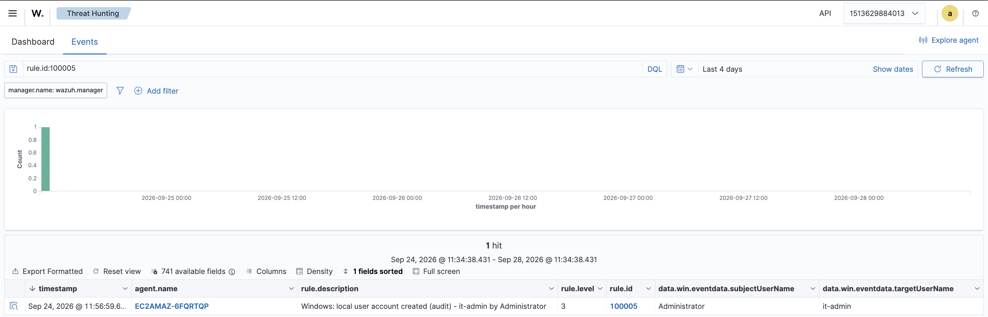
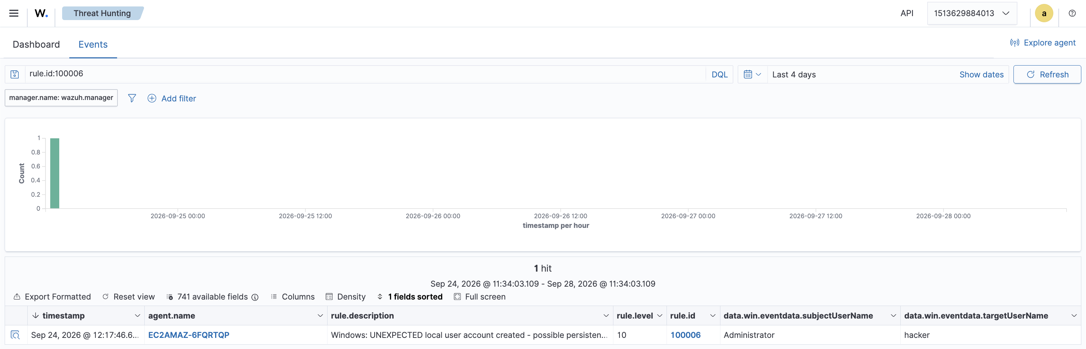

10.2 — SQL Injection: Fixing a Real False-Positive
The gap: The original rule alerted on any single quote in DVWA's id parameter, at level 10, every time — reviewer correctly pointed out that on a real free-text field, a legitimate apostrophe (e.g. O'Brien) would trigger the same high-severity alert. The rule couldn't distinguish reconnaissance from an actual attack.
The fix: Split into two tiers by attack grammar, not just character presence: rule 100004 (level 5, "recon") still fires on a bare quote, but at low severity. A new rule, 100007 (level 10, "attack grammar match"), only fires when the input matches real SQL injection structure — UNION SELECT, OR '1'='1', a SQL comment (--), DROP, etc. — patterns a legitimate value never produces by accident.
Verified live, all three cases: A clean id=1 request triggered nothing. A bare quote (id=1') triggered only the low-severity 100004. The full attack payload (id=1' OR '1'='1) triggered the high-severity 100007. All three were confirmed against the real running DVWA app, not just simulated in wazuh-logtest.
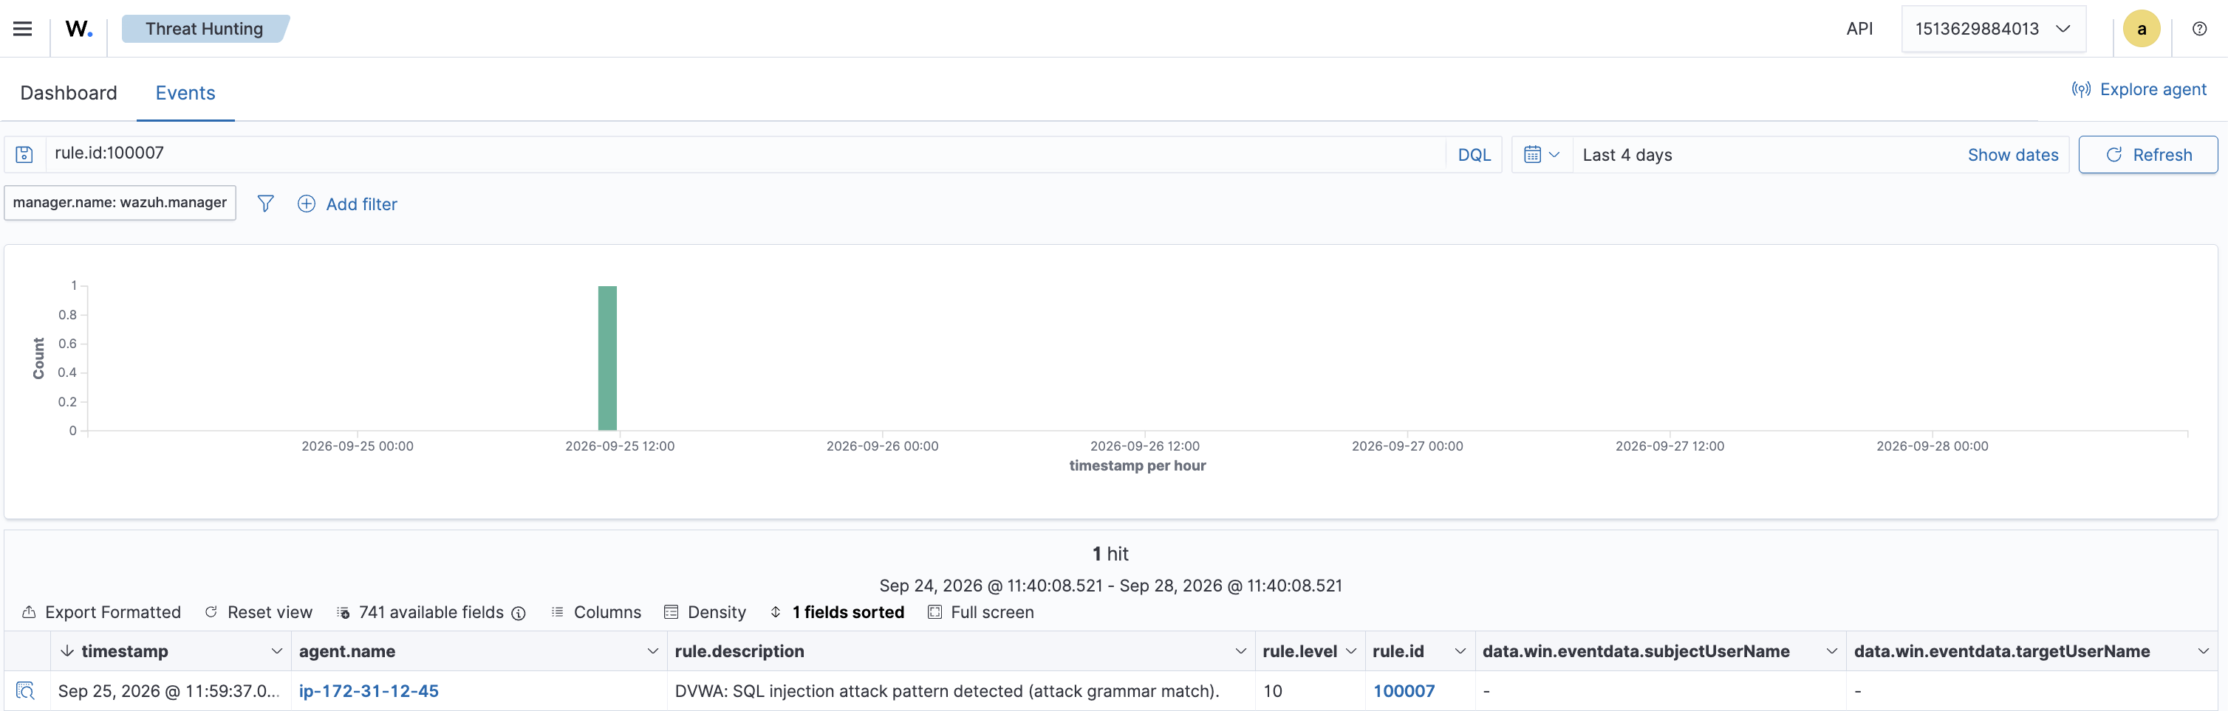
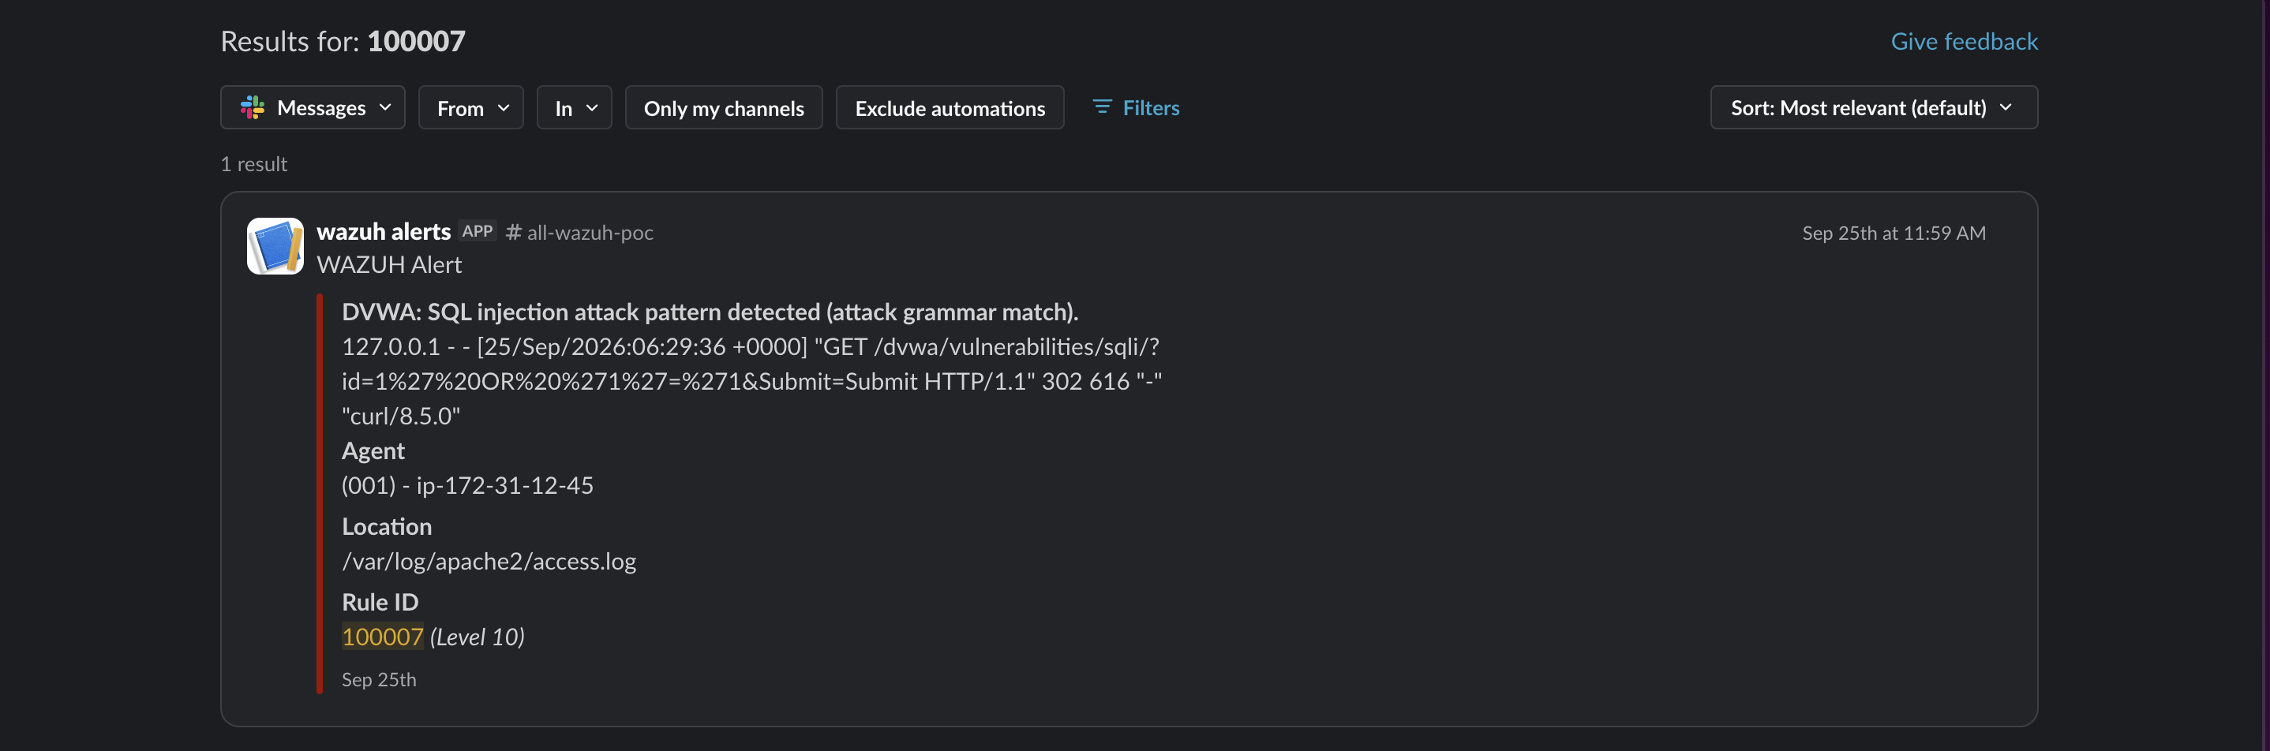Slack alert showing the level-10 SQL injection (rule 100007) message, distinct from the earlier blanket alert.
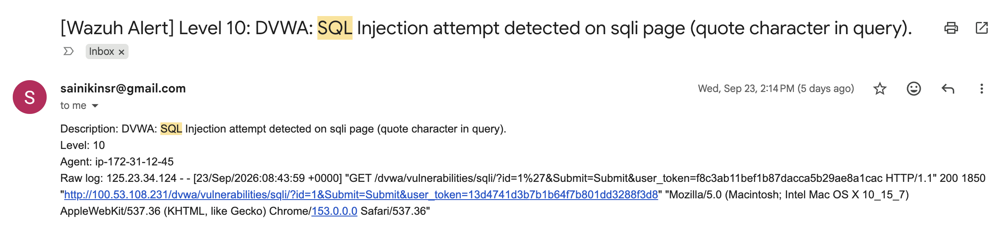
Email alert for the same rule 100007 match, showing rule id, level, agent, and MITRE T1190 tag.

10.3 — Brute Force: Investigating the Blocked IP From the Dashboard
The gap: The brute-force detection and auto-block both worked correctly, but there was no clean way to investigate the incident from the dashboard — who got blocked, and proof it was actually stopped, without dropping into a terminal.
The fix: Documented and verified a dashboard-only investigation workflow: Threat Hunting → Events, search rule.id:100003 to find the correlated alert and its data.srcip field (the attacker's IP), then pivot by searching that IP directly to pull its entire timeline — the failed login attempts, the correlation alert, and the active-response block event (rule 651) — all in one view, with no terminal required.
Verified: A real brute-force attempt (5 failed logins from the same IP within 120 seconds) produced the full expected chain — rule 100002 four times, rule 100003 once at level 10, rule 651 confirming the automatic firewall block, and rule 652 confirming the block auto-cleared after the timeout.
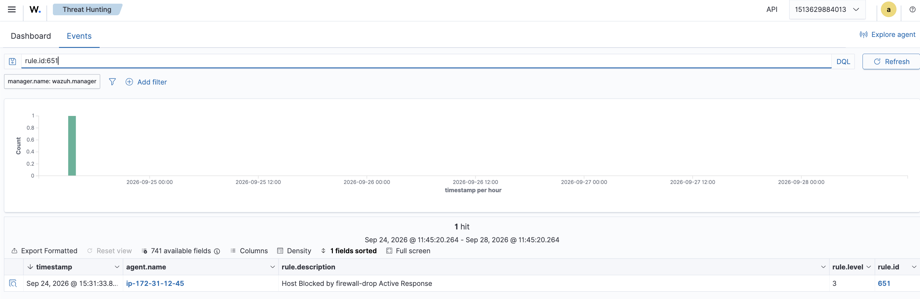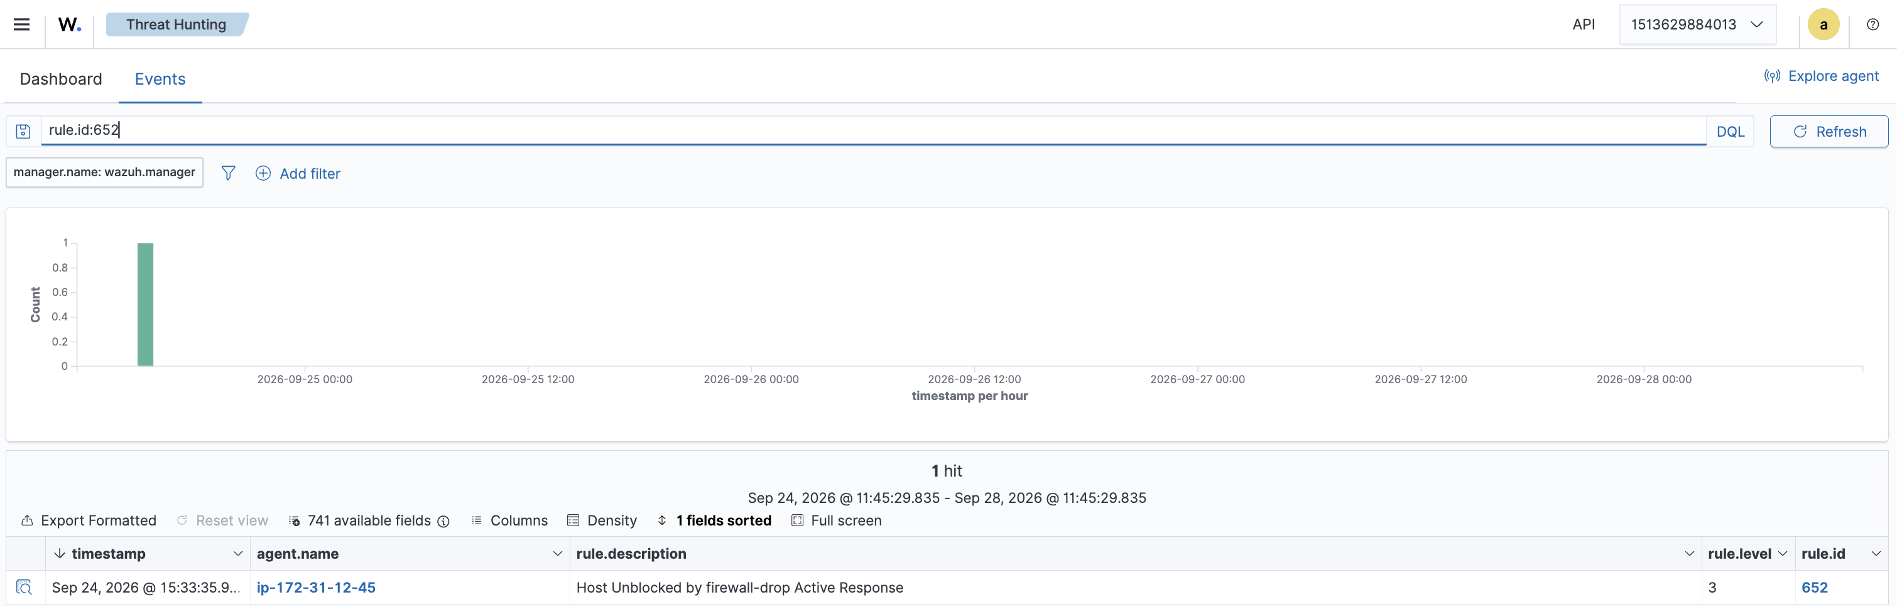

Key Learnings
- Agent-based monitoring is how you'd actually protect a home network with this. Basis was that to instal a lightweight Wazuh agent on any machine you care about, and it ships logs back to a central manager/indexer from there you get one place to see failed logins, suspicious web requests, whatever, across every device instead of digging through logs machine by machine.
- docker compose ps (and plain docker ps) became my go-to health check. Any time I touched a config file or restarted the stack, this was the first thing I ran to confirm all 3 containers (manager, indexer, dashboard) were actually Up and healthy before assuming anything else worked.
- Alerting isn't one-size-fits-all - I wired up both Slack and email for high-severity alerts, and learned along the way that Wazuh's built-in mailer only does old-school unauthenticated SMTP, so a custom Python integration was the real-world workaround for providers like Gmail that require proper auth.
- SOAR-style active response means the system reacts on its own, no human interaction was needed. Once a rule crosses a threshold (like 5 failed logins), Wazuh can automatically block that IP at the firewall level and I proved this wasn't just theoretical by triggering it against my own IP and literally losing SSH access for the full 2-minute timeout window before it auto-reversed. Best debugging accident of the whole project.
- Wazuh Dashboard visualizations turn raw alert data into something a SOC analyst could actually use at a glance - built out agent status, severity breakdowns, and custom DVWA detection panels myself using real indexed fields, not just default templates.

